Command Reference: WebGet()
Retrieve a file from a website
Version 09.06.03, 2010-04-05

The WebGet() command retrieves content from a website and writes the content to a local file. The transfer occurs using binary characters and the local copy is the same as that shown by View…Source (or View…Page Source) in the web browser. This command is useful for mining time series data from provider web sites. The local file can then be processed with additional commands such as ReadFromDelimitedFile().

Extraneous content (such as HTML markup around text) and inconsistencies in newline characters (\r\n for windows and \n on other systems) may lead to some issues in processing the content. Additional command capabilities may be implemented to help handle these issues.

The following dialog is used to edit the command and illustrates the syntax for the command. This example reads stream gage data from the State of Colorado’s website.

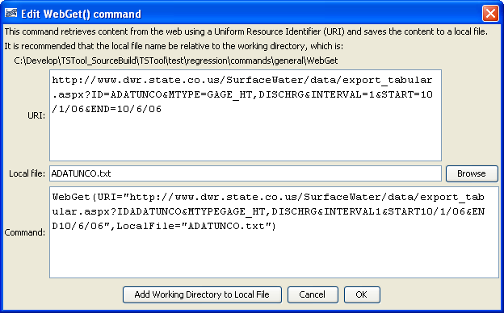
WebGet
WebGet() Command Editor

The command syntax is as follows:

WebGet(Parameter=Value,…)

Command Parameters

Parameter | Description | Default
URI | The Uniform Resource Identifier (URI) for the content to be retrieved. This is often also referred to as the Uniform Resource Locator (URL). | None – must be specified.
LocalFile | The local file in which to save the content. | None – must be specified.

