Command Reference: ManipulateTableString()
Manipulate string a string column in a table
Version 09.09.00, 2010-09-23

The ManipulateTableString() command manipulates a string column in a table. For example, it may be necessary to manipulate strings in a table in order to match time series identifier parts, so that lookups can occur.

The input is specified by a table column name (InputColumn1) and either a second input column name (InputColumn2) or a constant string value (InputValue2), with the result being placed in the output column (OutputColumn). Missing/blank input will be considered as empty strings when formatting the output.

The following dialog is used to edit the command and illustrates the syntax of the command (in this case illustrating how the contents of column String2 are prepended to the contents of a column named String1 and placed in the output column String3).

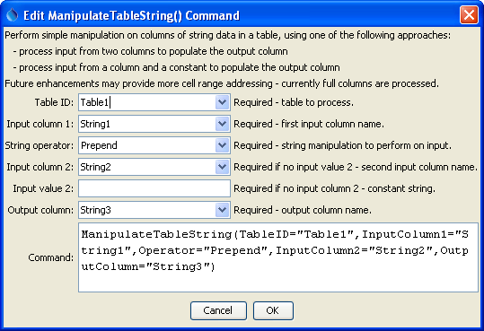
ManipulateTableString
ManipulateTableString() Command Editor

The command syntax is as follows:

ManipulateTableString(Parameter=Value,…)

Command Parameters

Parameter | Description | Default
TableID | The identifier for the table to process. | None – must be specified.
InputColumn1 | The name of a column containing strings, as the first input. | None – must be specified.
Operator | The operation to perform on the input strings. For example, Append will append the second input to the first input. | None – must be specified.
InputColumn2 | The name of a column containing strings, as the second input. | Required if InputValue2 is not specified.
InputValue2 | A string constant, as the second input. | Required if InputColumn2 is not specified.
OutputColumn | The name of a column to receive the output. | None – must be specified.

