Command Reference: SelectTimeSeries()
Select time series for additional processing
Version 09.09.00, 2010-09-23

The SelectTimeSeries() command selects output time series, as if done interactively, to indicate which time series should be operated on by following commands. The command minimizes the need for the Free() command, when used in conjunction with other commands that use a time series list based on selected time series (TSList=SelectedTS). See also the DeselectTimeSeries() command.

The following dialog is used to edit the command and illustrates the command syntax.

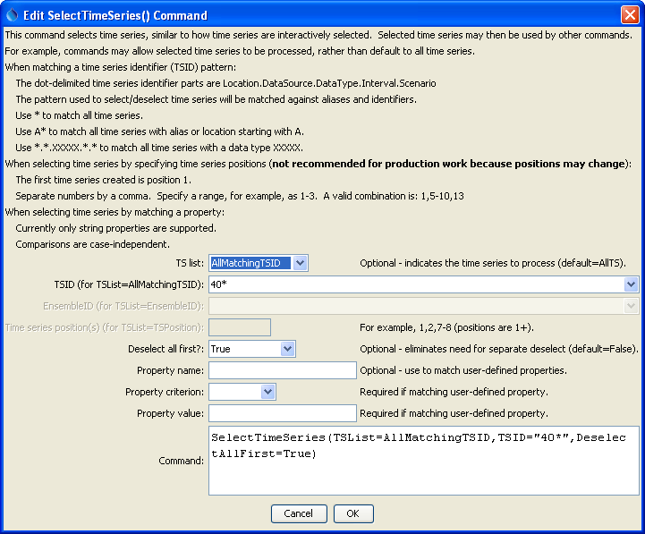
SelectTimeSeries
SelectTimeSeries() Command Editor

The command syntax is as follows:

SelectTimeSeries(Parameter=Value,…)

Command Parameters

Parameter | Description | Default
TSList | Indicates the list of time series to be processed, one of:  - AllMatchingTSID – all time series that match the TSID (single TSID or TSID with wildcards) will be modified.  - AllTS – all time series before the command.  - EnsembleID – all time series in the ensemble will be modified (see the EnsembleID parameter).  - LastMatchingTSID – the last time series that matches the TSID (single TSID or TSID with wildcards) will be modified.  - TSPosition – time series specified by position in the results list (see TSPosition parameter below). | AllTS
TSID | The time series identifier or alias for the time series to be modified, using the * wildcard character to match multiple time series. | Required if TSList=*TSID
EnsembleID | The ensemble to be modified, if processing an ensemble. | Required if TSList=EnsembleID
TSPosition | A list of time series positions (1+) in output, separated by commas. Ranges can be specified as Start-End. | Required if TSList=TSPosition
DeselectAllFirst | Indicates whether all time series should be deselected before selecting the specified time series: True or False. | False
PropertyName | Name of user-defined property to check.
PropertyCriterion | Criterion to evaluate to determine which properties match. | Required if PropertyName is specified.
PropertyValue | Value to check against the property value, using criterion. | Required if PropertyName is specified.

A sample command file is as follows:

TS 401234 = NewPatternTimeSeries(NewTSID="401234..Precip.Day",
Description="Example data",SetStart="2000-01-01",SetEnd="2000-12-31",
Units="IN",PatternValues="0,1,3,0,0,0")
SelectTimeSeries(TSList=AllMatchingTSID,TSID="40*",DeselectAllFirst=True)

