Command Reference: SetProperty()
Set a property for the time series processor
Version 09.08.02, 2010-09-23

The SetProperty() command sets the value of a property used by the time series processor, which means that the properties are available to all commands. These properties will ultimately be accessible by any command using ${Property} notation, for example to specify filenames more dynamically. However, currently only a few commands utilize the properties. This command should not be confused with the SetTimeSeriesProperty() command, which sets a property on specific time series.

The following dialog is used to edit this command and illustrates the syntax of the command.

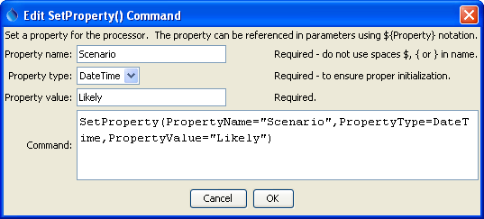
SetProperty
SetProperty() Command Editor

The command syntax is as follows:

SetProperty(Parameter=Value,…)

Command Parameters

Parameter | Description | Default
PropertyName | The property name. | None – must be specified.
PropertyType | The property type, used for validation, one of:  - DateTime – a date/time.  - Double – a floating point number  - Integer – an integer  - String – a string | None – must be specified.
PropertyValue | The value of the property, adhering to property type constraints. | None – must be specified.

A sample commands file is as follows:

SetProperty(PropertyName="Scenario",PropertyType=String,PropertyValue="Likely")

