5 Tools
Version 06.10.06, 2005-08-05, Color, Acrobat Distiller

This chapter discusses the tools available under the Tools menu. The Tools menu lists tools that perform additional analysis on time series that are selected in the Time Series Results list. These features are similar to the Results menu features in that a level of additional analysis is performed to produce the data product. Tools may or may not correspond to commands – often tools internally execute the features available in commands, in order to implement a more complicated analysis.

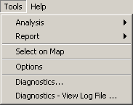
Menu_Tools
Tools Menu

5.1 Analysis Tools

Analysis tools analyze time series and typically produce an output report.

Menu_Tools_Analysis
Tools…Analysis Menu

Currently, only the Mixed Station Analysis tool is available, and it is under development (see the next section).

5.1.1 Mixed Station Analysis

This tool is under development.

The Mixed Station Analysis tool is an interactive tool that tries to find the best combination of time series necessary to fill data using regression or the MOVE2 method. The optimal results can then optionally be used as parameters for the fillMixedStation() command. The following figure illustrates the Mixed Station Analysis tool.

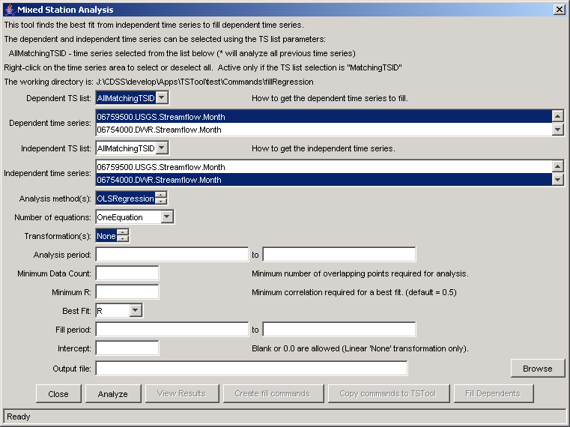
Menu_Tools_MixedStationAnalysis
Mixed Station Analysis Interface

5.2 Report Tools

Report tools analyze time series, typically creating a summary report.

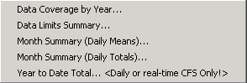
Menu_Results_Report
Tools…Report Menu

5.2.1 Data Coverage by Year Report

The Tools…Report - Data Coverage by Year menu processes the time series that have been selected and produces a report similar to the following (abbreviated). This report is useful, in particular, for evaluating data availability for multiple time series over a period. Although effort has been taken to make the report as compact as possible, it will likely need to be printed in landscape format on a large paper size.

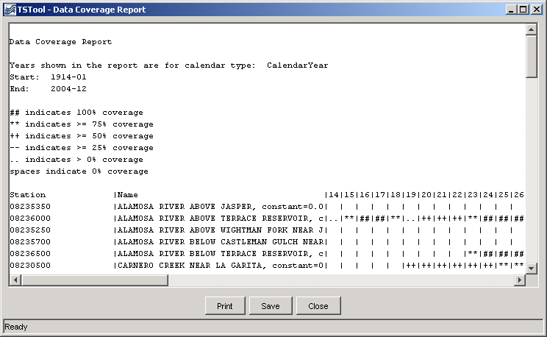
Menu_Results_Report_DataCoverage
Data Coverage by Year Report

5.2.2 Data Limits Summary Report

The Tools…Report - Data Limits Summary menu processes the time series that have been selected and produces a report similar to the following (abbreviated). The data limits summary for each time series is included. This report is useful, in particular, for evaluating data availability for specific time series. Currently, only monthly time series have detailed summaries. All other data intervals shown overall period summaries. The value -999 is used to indicate missing data.

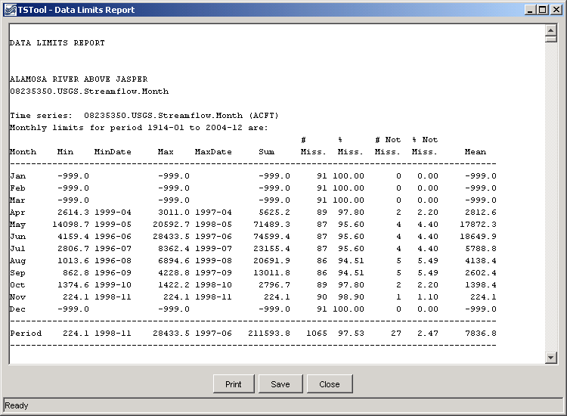
Menu_Report_DataLimits
Data Limits Summary Report

5.2.3 Month Summary Reports

The Tools…Report - Month Summary menus process the time series that have been selected and produces a report similar to the following (abbreviated). This report is similar to default summary output for monthly time series; however, it is applied to shorter data intervals, including minute, hour, and day interval. Values are first accumulated to daily values (by averaging the values in a day if the Daily Means report is chosen or by totaling the values in a day if the Daily Totals report is chosen). For example, use total for precipitation and means for average flows or daily temperature. The daily values are then further accumulated to produce monthly values, again using means or totals. The report includes a header for the time series, the report, and footnotes. Values are only shown if full data are available for a month and statistics are computed using only complete months.

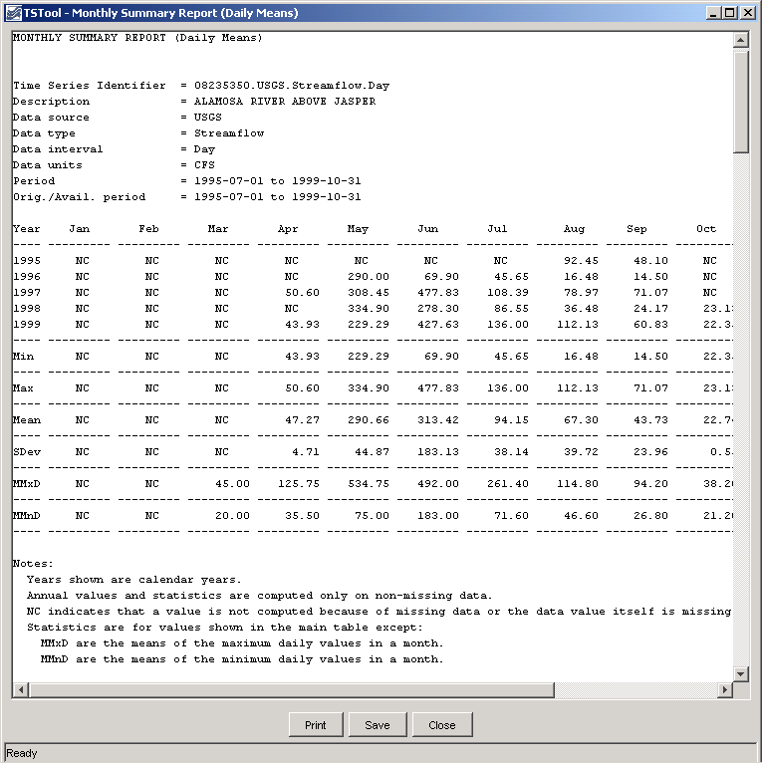
Menu_Tools_MonthSummaryDailyMean
Monthly Summary (Daily Mean) Report

5.2.4 Year to Date Total Report

The Tools…Report - Year to Date Total menu processes the time series that have been selected and produces a report similar to the following (abbreviated). This report is useful, in particular, for comparing on a volumetric basis the different years of a time series over a full period. The year to date volumes are sorted; to find a particular year, use the Search button on the report display. The report information can then be used, for example, to select time series traces for analysis and output. Currently, this report can only be used to process daily CFS data. Real-time data can be analyzed by first converting to a daily interval using the changeInterval() command. Warning: some years may have no data at the beginning of a year and the corresponding year-to-date totals will consequently be zero. Refer to the data coverage and data limit reports for more detail.

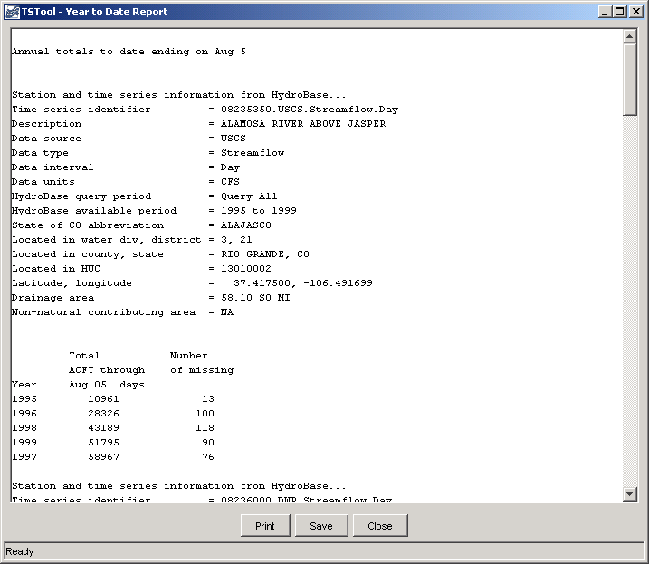
Menu_Tools_Report_YearToDateTotal
Year to Date Total Report

5.3 NWSRFS Tools

The National Weather Service River Forecast System (NWSRFS) uses time series extensively and a number of tools are available in TSTool specifically for NWSRFS data.

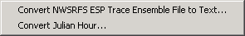
Menu_Tools_NWSRFS
Tools…NWSRFS Menu

5.3.1 Convert NWSRFS ESP Trace Ensemble File to Text

The Tools…NWSRFS…Convert NWSRFS ESP Trace Ensemble File to Text menu converts a binary conditional ESP Trace Ensemble file (*.CS) to a text file, as follows:

- Select the ESP Trace Ensemble file.
- Select the output text file. By default the file name is the same as that from step 1, with an additional .txt extension.
- Specify the output units for the text file. This is provided because ESP Trace Ensemble files are written using SI units. For example, an ESP Trace Ensemble file with units of CMS can be converted to CFS during output.

The resulting output is similar to the following:

Values from ESP Trace Ensemble Header:
FormatVersion = 1.01
SequenceNumber = 1990 1991 1992 1993 1994 1995 1996 1997 …
Segment = "CSCI"
SegmentDescription = "1990"
Location = "CSCI"
CarryoverGroup = ""
ForecastGroup = ""
DataType = "SQIN"
Interval = 6
SimFlag = 3
DataUnits = "CFS"
CreationDate = "2004-06-02 15:50:00"
idarun = 33146
im = 10
iy = 1990
ldarun = 33450
ijdlst = 37529
ihlst = 5
CarryoverDateLocal = 2002-10-01 05 MST
ForecastStartLocal = 2002-10-01 11 MST
ljdlst = 37833
lhlst = 16
ForecastEndLocal = 2003-08-01 16 MST
NumTraces = 28
NCM = 11
TimeZone = -7
noutds = 0
Irec = 2
Dimension = "L3/T"
MeasTimeScale = "INST"
Latitude = 0.0
Longitude = 0.0
RFC = ""
PRSFFlag = 0
UserComments = ""
Note: Output below has been converted from "CFS to "CFS"
Note: The first column below shows the start year of the historical trace and the corresponding start of month's date in forecast time).
1990 2002-11-01 06 -999.00 -999.00 4627.12 8721.91 6560.91 2439.81 …
314.53 310.51 306.78 303.27 299.06 295.42 …
359.36 350.11 342.33 335.06 328.00 320.09 …
232.56 228.82 223.89 218.26 214.27 209.49 …
1990 2002-12-01 06 163.01 159.33 156.90 155.45 153.83 151.39 …

… continue for all data records …

5.3.2 Convert Julian Hour

NWSRFS uses Julian dates and hours, to allow software to iterate through data and compute time differences. The conversion of Julian date/time to calendar date/time can be confusing. The Tools…NWSRFS…Convert Julian Hour tool facilitates converting to/from Julian date/time.

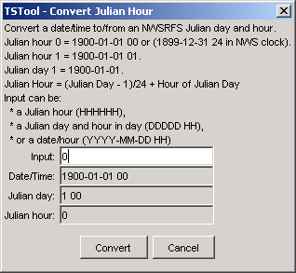
Menu_Tools_NWSRFS_ConvertJulianHour
NWSRFS Convert Julian Hour Tool

NWSRFS uses hour 1-24 whereas TSTool uses 0-23. Therefore, the results of the tool should be interpreted considering the NWSRFS conventions.

5.4 Map Tools

The Tools…Show on Map button is enabled when a map is displayed (using View…Map) and time series are listed in the upper right part of the main window. The locations corresponding to selected time series or all time series in this list can be displayed on the map. See Chapter 8 – Using the Map for more information.

5.5 Diagnostics

Diagnostics features are useful for troubleshooting. When an error occurs, a small warning dialog may be displayed, as shown in the following figure:

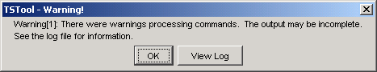
Diagnostics_Warning
Example Warning Message Dialog

If results are not as expected, also review the messages in the status bar at the bottom of the main or secondary windows.

5.5.1 Diagnostics Settings

The Tools…Diagnostics menu item displays the Diagnostics dialog, which is used to set message levels and view messages as the application runs. The Diagnostics dialog (see the following figure) can be used to evaluate a problem.

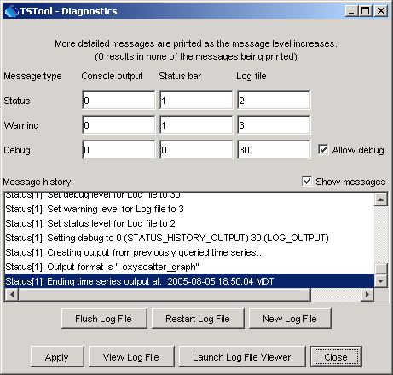
Diagnostics
Diagnostics Interface

The settings at the top of the dialog are used to specify the level of detail for messages printed to the console window, the status area at the bottom of the main window (and the Diagnostics dialog), and the log file. The log file contains warning, status, and debug messages, many of which are not normally displayed in the main interface. The log file is created in the logs directory under the installation directory. The Diagnostics interface features are as follows:

Status, Warning, Debug |  | Enter integer values, with larger numbers resulting in more output and slower performance. Zero indicates no output. If troubleshooting, a good guideline is to set the debug level to 10 or 30 (and select the Allow Debug checkbox). The default settings are often enough for normal troubleshooting and result in good software performance.
Allow Debug |  | Select to enable debug messages. Turning on debug messages will significantly slow down the software.
Show Messages |  | Select to display messages in the Diagnostics window.
Flush Log File |  | Force messages to be written to the log file. Messages can be buffered in memory and may not otherwise immediately be written to the log file.
Restart Log File |  | Restart the log file. This is useful if a long session has occurred and troubleshooting will occur on new actions.
New Log File |  | Open a new log file, with a new name.
Apply |  | Apply the settings in the Diagnostics dialog.
View Log File |  | View the log file in an integrated window. The View Log File button will be enabled if the log file has been opened.
Launch Log File Viewer |  | View the log file using a viewer from the operating system. On Windows computers, Notepad will be used.
Close |  | Apply the settings in the Diagnostics dialog and close the window.

5.5.2 Diagnostics – View Log File

The Tools…Diagnostics – View Log File menu item displays the integrated log file viewer. Selecting this menu item is equivalent to selecting the View Log File button in the Diagnostics dialog. The log file viewer will be displayed in a window as shown in the following figure:

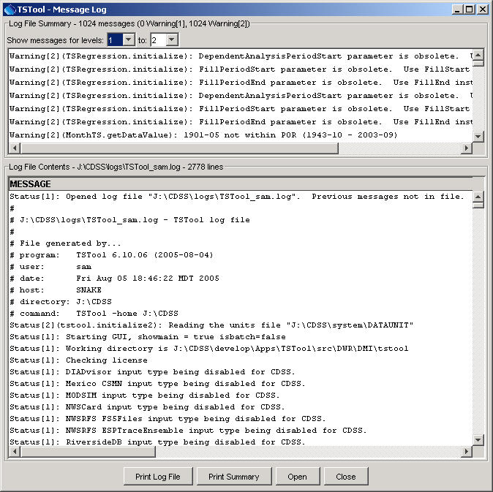
Diagnostics_ViewLog
Log File Viewer Window

The log file messages can be scrolled. To find a string in the log file, right-click and select the Find menu item. The information in the log file can also be copied and pasted into email, when contacting support.

