Command Reference: Time Series Identifier (TSID) Command for StateMod Files
Read a single time series from a StateMod file
Version 06.17.00, 2006-04-28, Color, Acrobat Distiller

A StateMod time series identifier (TSID) command of the form:

LocationID…Interval~StateMod~Filename

indicates that TSTool should read the time series from a StateMod text time series file. Refer to the StateMod Input Type appendix for a full description of the file format. A similar TSID command exists to read time series from StateMod binary files (StateModB input type). A StateMod TSID command is generated as follows:

- Select the StateMod input type and appropriate time step in the main TSTool window.
- Press the Get Time Series List button to list time series. A dialog will prompt for the StateMod file and after selection the first year of data from the file will be read to get a list of identifiers. The interval that is specified (Month or Day) indicates whether the file is a monthly or daily format. The time series will be listed in the time series list in TSTool.
- Select one or more time series from the list and copy to commands.

The following dialog is used to edit the command and illustrates the syntax of the command. A generic command editor dialog is used and error checks are not performed. There is currently no way to automatically convert an absolute path to a relative path; therefore, use the command editor to adjust the path from absolute to relative, if appropriate.

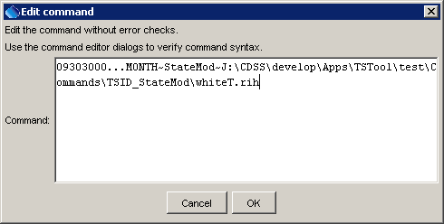
TSID_StateMod
StateMod TSID Command Editor

After executing the command, the time series will have the identifier as originally requested, with no alias being assigned. There is currently no equivalent TS Alias = readStateMod() command, although this command is planned.
A sample commands file is as follows (in this case the absolute paths have been adjusted to relative paths using the command editor dialog):

09303000...MONTH~StateMod~whiteT.rih
09303400...MONTH~StateMod~whiteT.rih

