Command Reference: blend()
Append a Time Series to the End of Another Time Series
Version 06.08.02, 2004-08-03, Color, Acrobat Distiller

The blend()command blends one time series into another, extending the first time series period if necessary. This is typically used for combining time series for a station that has been renamed or to blend historic and real-time data. See also the setFromTS() and add() commands. The blend() command ensures that single values are used whereas add() may add values at the same date/time. The setFromTS() does not extend the period.

The following dialog is used to edit the command and illustrates the syntax of the command.

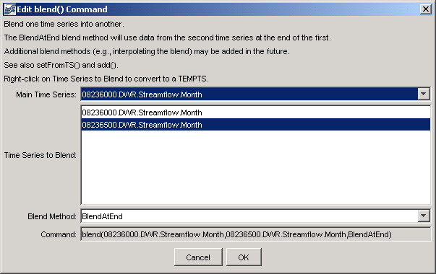
blend
blend() Command Editor

The command syntax is as follows:

blend(TSID,TSID2,BlendMethod)

Command Parameters

Parameter | Description | Default
TSID | The time series identifier or alias for the time series to be modified. | None – must be specified.
BlendTSID | The time series identifier or alias for the time series to be blended to the first time series. Right clicking on a time series to blend allows toggling of the TEMPTS key word. This will cause the time series to add to be read and then discarded, simplifying the input file. However, to insert the time series the first time, the time series must have been listed in the commands file as a time series identifier. | None – must be specified.
BlendMethod | The date/time to start analyzing data. The only blend method currently supported is BlendAtEnd, resulting in the main time series having the other time series attached to the end of its period. | None – must be specified.

A sample commands file is as follows:

# 08236000 - ALAMOSA RIVER ABOVE TERRACE RESERVOIR
08236000.DWR.Streamflow.Month~HydroBase
# 08236500 - ALAMOSA RIVER BELOW TERRACE RESERVOIR
08236500.DWR.Streamflow.Month~HydroBase
blend(08236000.DWR.Streamflow.Month,08236500.DWR.Streamflow.Month,BlendAtEnd)

