Command Reference: convertDataUnits()
Convert Time Series Data from One Set of Units to Another
Version 06.08.02, 2004-08-03, Color, Acrobat Distiller

The convertDataUnits() command converts the data units for a time series (e.g., before output to a file). Note that some read and write commands also allow units to be converted.

The following dialog is used to edit the command and illustrates the syntax of the command.

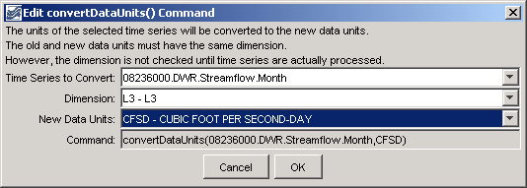
convertDataUnits
convertDataUnits() Command Editor

The Dimension choice should be selected to narrow the list of available units to the appropriate dimension. Next, select the New Data Units for the time series. The list of available data units is taken from the information described in the TSTool DATAUNITS file (see the TSTool Installation and Configuration Appendix for more information). If desired units are not available, contact the TSTool developers to suggest adding units to the DATAUNITS file or edit the command manually after initial creation.

Note that the dialog cannot display the current units for the time series because the units are not available until time series are actually processed – commands are edited before processing.

The command syntax is as follows:

convertDataUnits(TSID,NewUnits)

Command Parameters

Parameter | Description | Default
TSID | The time series identifier or alias for the time series to be modified. A single time series identifier/alias can be selected, or the asterisk (*) can be selected to convert all time series. | None – must be specified.
NewUnits | The new data units. | None – must be specified.

A sample commands file is as follows:

# 08236000 - ALAMOSA RIVER ABOVE TERRACE RESERVOIR
08236000.DWR.Streamflow.Month~HydroBase
convertDataUnits(08236000.DWR.Streamflow.Month,CFSD)

