Command Reference: cumulate()
Convert time series data values to cumulative values
Version 06.10.09, 2005-09-30, Color, Acrobat Distiller

The cumulate()command converts a time series into cumulative values, which is useful for comparing the cumulative trends of related time series (e.g., nearby gages or precipitation gages) and can serve as a substitute for the double-mass graph, which has difficulty handling missing data. It is also useful to check the mass balance when routing time series (the cumulative values before and after routine will track closely). The following dialog is used to edit the command and illustrates the syntax of the command.

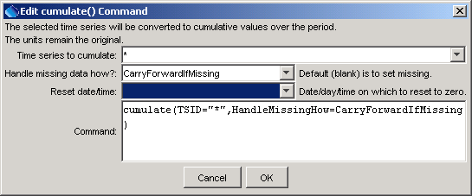
cumulate
cumulate() Command Editor

The command syntax is as follows:

cumulate(param=value,…)

Command Parameters

Parameter | Description | Default
TSID | The time series identifier or alias for the time series to be modified. A single TSID/alias or all time series (*) can be specified. | None – must be specified.
Handle  Missing  How | Indicate how to handle missing data, one of:  - CarryForwardIfMissing –carry forward the last non-missing value  - SetMissingIfMissing – set the result to missing if the original value is missing.  The only difference in output is that the period of missing data will either be blank or a horizontal line in graphs. | SetMissing  IfMissing
Reset | A MM-DD date, day (1-31), or month (1-12) indicating when to reset the cumulative value to zero, before beginning to cumulate again. The features of this parameter are under development. | Do not reset.

A sample commands file is as follows:

# 1458 - CENTER 4 SSW
1458.NOAA.Precip.Month~HydroBase
# 2184 - DEL NORTE 2 E
2184.NOAA.Precip.Month~HydroBase
cumulate(TSID=”*”,HandleMissingHow=CarryForwardIfMissing)

The following graph illustrates cumulative data for two precipitation gages in the same region, where missing data results in carrying forward the last known value.

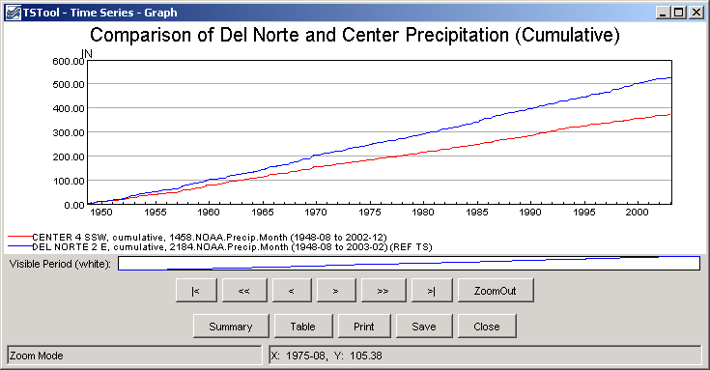
cumulate_graph
Example Graph Showing Results of cumulate() Command

