Command Reference: fillCarryForward()
Fill Missing Time Series Data by Carrying Data Forward
Version 06.08.02, 2004-07-29, Color, Acrobat Distiller

This command has been replaced by fillRepeat().

The fillCarryForward() command fills a time series by carrying forward observations until another observation is found. This fill technique is useful, for example, where time series are likely to be step-wise or nearly constant, such as some reservoir and diversion time series. Currently there is no constraint to limit the number of intervals over which the filling will occur. There is also no way to limit the fill operation to a period (the entire time series is filled). The following dialog is used to edit the command and illustrates the syntax of the command.

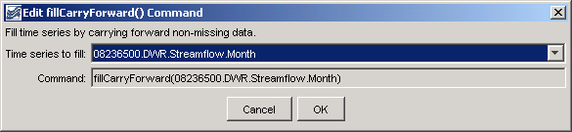
fillCarryForward
fillCarryForward() Command Editor

The command syntax is as follows:

fillCarryForward(TSID)

Command Parameters

Parameter | Description | Default
TSID | The time series identifier or alias for the time series to be filled. Specify as * to fill all time series. | None – must be specified.

A sample commands file is as follows:

# 08236500 - ALAMOSA RIVER BELOW TERRACE RESERVOIR
08236500.DWR.Streamflow.Month~HydroBase
fillCarryForward(08236500.DWR.Streamflow.Month)

This page is intentionally blank.

