Command Reference: fillInterpolate()
Fill Missing Time Series Data by Interpolating Between Known Values
Version 06.08.02, 2004-08-02, Color, Acrobat Distiller

The fillInterpolate() command fills missing data in a time series by interpolating between known values within the same time series. There is currently no way to limit the fill operation to a period (the entire time series is filled). The following dialog is used to edit the command and illustrates the syntax of the command.

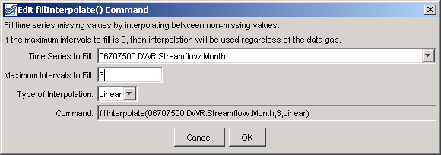
fillInterpolate
fillInterpolate() Command Editor

The command syntax is as follows:

fillInterpolate(TSID,MaxIntervals,Transformation)

Command Parameters

Parameter | Description | Default
TSID | The time series identifier or alias for the time series to be filled. Specify * to fill all time series. | None – must be specified.
MaxIntervals | The maximum number of consecutive intervals to fill (0 indicates no limits on the number of consecutive intervals that can be filled). | None – must be specified.
Transformation | Indicate the data transformation to occur for interpolation. Currently, Linear is the only option. | None – must be specified.

A sample commands file is as follows:

# 06707500 - SOUTH PLATTE RIVER AT SOUTH PLATTE
06707500.DWR.Streamflow.Month~HydroBase
fillInterpolate(06707500.DWR.Streamflow.Month,3,Linear)

