Command Reference: fillMOVE2()
Fill missing data in time series using the Maintenance of Variance Extension (MOVE.2) procedure
Version 06.16.01, 2006-04-17, Color, Acrobat Distiller

The fillMOVE2() command fills missing data in a time series using the MOVE.2 procedure (see the fillMOVE1() command for background information). The MOVE.2 procedure uses the Two-Station Comparison procedure described in Appendix 7 of Bulletin 17B, Guidelines for Determining Flood Flow Frequency, USGS, to compute improved estimates of the mean and variance at the dependent or short-term station and uses all the data at the dependent time series to estimate the mean and variance of the dependent time series. The MOVE.2 procedure has been shown to be marginally better than MOVE.1. The following MOVE.2 equation is used to estimate values for the dependent time series from the independent time series:
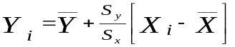
where

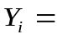discharge for dependent time series
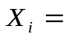discharge for independent time series
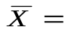mean for independent time series for 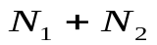 years ( N ₂ is the additional years in the long-term time series)
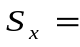standard deviation for independent time series for years

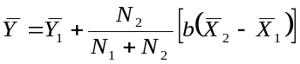 | (Equation 7-5a for Two-Station Comparison in Appendix 7 of Bulletin 17B)

(Equation 7-10 for Two-Station Comparison in Appendix 7 of Bulletin 17B)
where
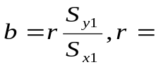correlation coefficient (Note that b is the slope of the ordinary least squares regression line.)
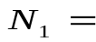concurrent or overlapping period of record
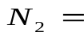additional years available at long-term site
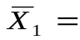mean of independent time series for 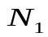years
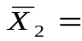mean of independent time series for 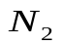years
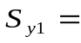standard deviation of dependent time series for years
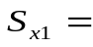standard deviation of independent time series for years

The following dialog is used to edit the command and illustrates the command syntax.

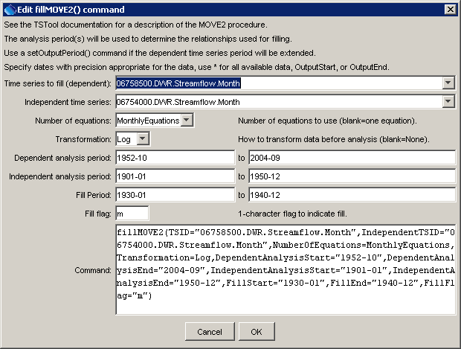
fillMOVE2
fillMOVE2() Command Editor

The command syntax is as follows:

fillMOVE2(param=value,…)

Command Parameters

Parameter | Description | Default
TSID | The time series identifier or alias for the time series to be filled (dependent time series). | None – must be specified.
IndependentTSID | The time series identifier or alias for the independent time series, to supply data. | None – must be specified.
NumEquations | OneEquation or MonthlyEquations, indicating how many relationships are to be determined. | OneEquation
Transformation | Log or None, indicating the type of data transformation. If the Log option is used, zero and negative values are set to .001 (-999 values are treated as missing data and are ignored), and the data values are transformed using log10. | None
Dependent  Analysis  Start/End | The period for N₁ (overlapping data) that is used to analyze the dependent time series. For example, this may be the unregulated period for streamflow data. Typically, this is longer than the independent analysis period. | Analyze the full period.
Independent  Analysis  Start/End | The period for N₂ (non-overlapping data) that is used to analyze the independent time series. For example, this may be the unregulated period for streamflow data. | Analyze the full period.
FillStart | The date/time to start filling. | Fill the full period.
FillEnd | The date/time to end filling. | Fill the full period.
FillFlag | A single character to be used to flag filled points on graphs and other output. | Do not flag filled data.

A sample commands file is as follows:

startLog(LogFile="commands.TSTool.log",Suffix="Date")
setOutputPeriod(1901-01,2004-12)
# 06758500 - SOUTH PLATTE RIVER NEAR WELDONA
06758500.DWR.Streamflow.Month~HydroBase
# 06754000 - SOUTH PLATTE RIVER NEAR KERSEY
06754000.DWR.Streamflow.Month~HydroBase
fillMOVE2(TSID="06758500.DWR.Streamflow.Month",
IndependentTSID="06754000.DWR.Streamflow.Month",
NumberOfEquations=MonthlyEquations,Transformation=Log,
DependentAnalysisStart="1952-10",DependentAnalysisEnd="2004-09",IndependentAnalysisStart="1901-01",IndependentAnalysisEnd="1950-12",
FillStart="1930-01",FillEnd="1940-12",FillFlag="m")

This page is intentionally blank.

