Command Reference: fillMixedStation()
DRAFT - THIS COMMAND IS BEING DEVELOPED
Fill missing time series data using the best fit from OLS regression or MOVE2, multiple independent time series and data transformats, optionally by month
Version 06.10.00, 2005-04-06, Color, Acrobat Distiller

The fillMixedStation() command fills missing data in a time series using ordinary least squares (OLS) regression (see the fillRegression() command for details) or MOVE2 (see the fillMOVE2() command for details). This command first performs an analysis to determine the combination of one or more independent time series, data transformation(s), and analysis method(s), using monthly or a single equation. The resulting best fit, based on standard error of prediction, is then used to fill the time series. The best combination is used first to fill as much data as possible, the remaining missing data are filled with the second best fit, etc. Because extensive analysis may be necessary to evaluate all the combinations of parameters, this command will be slower than other commands that specifically indicate how to perform the filling. Performance can be increased by using the Mixed Station Analysis tool to determine time series that result in the best fit, and excluding all other time series in the fill command.

The results of the analysis are printed to a report file. The analysis may require some iteration and review of results to determine the best stations to use for fillings; therefore, an interactive tool is provided to help analyze data. The results of this tool can be used to create commands for automated processing.

Mixed Station Analysis Tool

The Mixed Station Analysis tool is started after time series have been queried in TSTool (it will be disabled until time series are available). The following dialog illustrates the parameters of the tool, which are essentially the same as for the fillMixedStation() command (see next section).

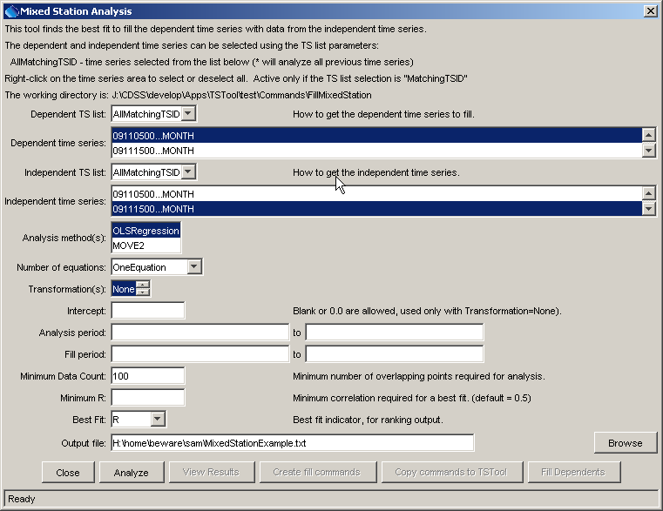
tool_MixedStationAnalysis1
Mixed Station Analysis Tool after Initial Display

The tool is used to generate an analysis report and therefore multiple dependent and independent time series can be selected. To select all, right-click on the time series lists and select from the popup menu. The criteria for determining best fit must be selected as the correlation coefficient ( R ), the standard error of prediction (SEP), or the total SEP (see parameter description below).

Once dependent and independent time series are selected for analysis, and suitable parameters are entered, press the Analyze button. The analysis may take several minutes or more, depending on the number of time series being processed (performance is being evaluated). It is recommended that an initial analysis evaluate all time series as independent and dependent but after initial results are reviewed that the tool be applied on specific dependent time series. When the analysis is complete, the View Results button will be enabled. If the results are satisfactory, then the Create fill commands button can be used to create commands suitable for use in TSTool. The commands can be reviewed and if satisfactory, can be copied to TSTool using the Copy commands to TSTool button (this link is not yet enabled). Similar to adding other commands the commands will be copied to the end of the commands file or inserted above the first selected line.

Question, for specific time series, should the filling sequence be to fill as much data as possible with the first choice and then move to the next choice, or is more control needed?

Subsequent edits of the command can occur by selecting the command. The following section provides an example of the standard command editor and a description of all of the parameters.

Command Editing

The following dialog is used to edit the command and illustrates the syntax of the command:

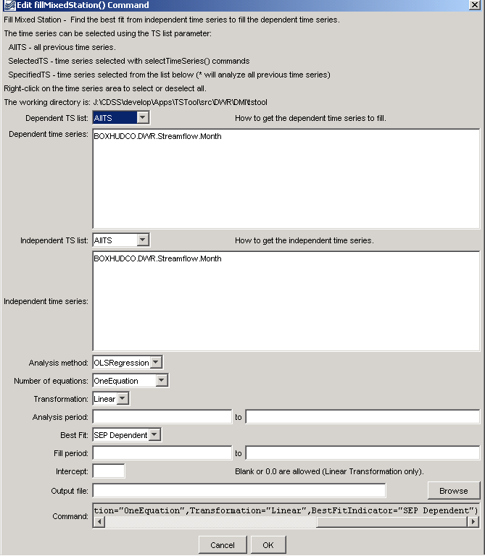
fillMixedStation
fillMixedStation() Command Editor
The command syntax is as follows:

fillMixedStation(param=value,…)

Command Parameters

Parameter | Description | Default
DependentTSList | Indicates how the list of dependent time series is specified, one of:  - AllTS – all time series prior to the command.  - SelectedTS – the time series are those selected with the selectTimeSeries() command.  - MatchingTSID – the specified list of time series given by the DependentTSID parameter. | None – must be specified.
DependentTSID | The time series identifier or alias for the independent time series to be filled. Specify as a single TSID or a comma-separated list of TSIDs, surrounded by double quotes. | Must be specified if DependentTSList=  SpecifiedTS, ignored otherwise.
IndependentTSList | Indicates how the list of independent time series is specified, one of:  - AllTS – all time series prior to the command.  - SelectedTS – the time series are those selected with the selectTimeSeries() command.  - MatchingTSID – the specified list of time series given by the DependentTSID parameter.  If an independent time series matches the independent time series, the analysis combination will be skipped. | None – must be specified.
IndependentTSID | The time series identifier or alias for the independent time series to be compared. Specify as a single TSID or a comma-separated list of TSIDs, surrounded by double quotes. | Must be specified if IndependentTSList=  SpecifiedTS, ignored otherwise.
AnalysisMethod | Specify the method(s) to analyze the data, in order to determine the best fit, including OLSRegression and/or MOVE2. If multiple methods are specified, separate with commas. Include in double quotes.
NumberOfEquations | The number of equations to use for the analysis: OneEquation or MonthlyEquations. | None – must be specified.
Transformation | Indicates how to transform the data before analyzing. Specify as Linear (no transformation) or Log (for Log₁₀). If the Log option is used, zero and negative values are set to .001 (-999 values are typically treated as missing data and are ignored). If multiple values are selected, separate with a comma. Include in double quotes. | No transformation.
AnalysisStart | The date/time to start the analysis, to focus on a period appropriate for analysis. For example, specify the unregulated period for streamflow. | If blank, analyze the full overlapping period.
AnalysisEnd | The date/time to end the analysis. | If blank, analyze the full overlapping period.
MinimumDataCount | The minimum number of overlapping data points that are required for a valid analysis (N1 in fillRegression() and fillMOVE2() documentation). If the minimum count is not met, then the independent time series is ignored for the specific combination of parameters. For example, if monthly equations are used, the independent time series may be ignored for the specific month; however, it may still be analyzed for other months. | None – must be specified.
MinimumR | The minimum correlation coefficient required for a best fit. If the minimum is not met, then the results are not considered in the best fit ranking. | 0.5
BestFitIndicator | Specifies the indicator to use when determining the best fit, one of:  - R (correlation coefficient).  - SEP (Standard Error of Prediction), defined as the square root of the sum of differences between the known dependent value, and the value determined from the equation of best fit at the same point.  - SEPTotal, when used with one equation, it is the same as SEP. When used with monthly equations, it is the average error considering all months. | SEP (Standard Error of Predition).
FillStart | The date/time to start filling, if other than the full time series period. | If blank, fill the full period.
FillEnd | The date/time to end filling, if other than the full time series period. | If blank, fill the full period.
Intercept | Specify as 0 to force the intercept of the best-fit line through the origin. This is made available only for OLS regression analysis on untransformed data. | Parameter is optional and if specified the default is to not force the intercept through zero.
OutputFile | Output file for the results, either as a file name to be written to the working directory, or a full path. | If not specified, partial results of the analysis may be available in the log file.

A sample commands file is as follows:

Will need an example.

