Command Reference: fillProrate()
Fill Missing Time Series Data by Prorating Values in Another Time Series
Version 06.10.05, 2005-08-04, Color, Acrobat Distiller

The fillProrate() command fills missing data in time series by prorating values from another time series. This fill technique is useful, for example, where two time series are likely to have the same general trend and ratio of data values. The ratio can be computed two ways, as specified by the ComputeFactorHow parameter:

- NearestPoint – causes the ratio to be recomputed each time that a non-missing value is found in both time series. The ratio is therefore used for filling until another value can be computed.
- AnalyzeAverage – computes the ratio as the average ratio of the time series and the independent time series. This was implemented to match an existing fill procedure but can lead to some bias in the results. A different overall average will be obtained depending on whether ratios are computed first and then averaged than if the sum of the numerators are added and divided by the sum of the denominators. In the former, the choice of which time series is in the denominator could impact results.

The initial computation of the ratio may require specifying an initial value due to missing data on the end-points of the time series (see the InitialValue parameter). Alternatively, the time series can be filled in one direction first and then filled in the other direction with a second command.

The following dialog is used to edit the command and illustrates the syntax of the command:

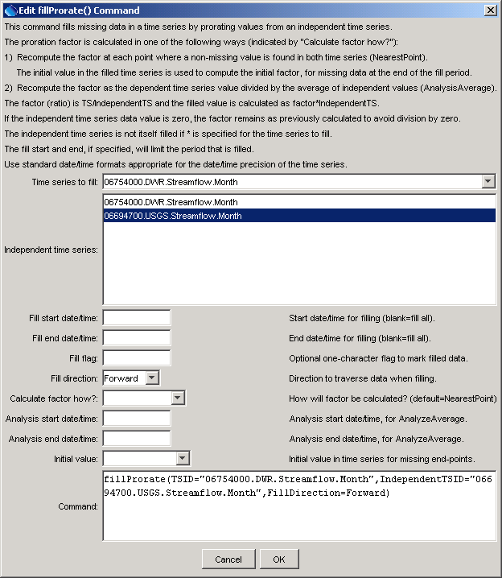
fillProrate
fillProrate() Command Editor

The command syntax is as follows:

fillProrate(param=value,…)

Command Parameters

Parameter | Description | Default
TSID | The time series identifier or alias for the time series to be filled. Specify as * to fill all time series. Currently a pattern other than * is not supported. | None – must be specified.
IndependentTSID | The time series identifier or alias for the independent time series. | None – must be specified.
FillStart | The starting date/time for the fill. | Available period.
FillEnd | The ending date/time for the fill. | Available period.
FillFlag | A one-character flag to tag data values that are filled. | None – do not flag filled data.
FillDirection | Specify the direction of the fill as Forward or Backward. | Forward
CalculateFactorHow | Specify how to calculate the factor to use in proration, one of:  - AnalyzeAverage – to calculate the factor of the average of the time series divided by the independent time series, using the analysis period.  - NearestPoint – calculate the factor at the nearest point where both time series have non-missing values. | NearestPoint
AnalysisStart | The starting date/time for the analysis, used when CalculateFactorHow=AnalysisAverage. | Analyze the full period.
AnalysisEnd | The ending date/time for the analysis, used when CalculateFactorHow=AnalysisAverage. | Analyze the full period.
InitialValue | The initial value to use for the filled time series, for cases where a value may not be available on the ends of the fill period, one of:  - NearestBackward – search the time series backward for the nearest non-missing value.  - NearestForward – search the time series forward for the nearest non-missing value.  - Specify a number to use for the initial value. | None – filling will not occur at the end.

A sample commands file is as follows:

# 06754000 - SOUTH PLATTE RIVER NEAR KERSEY
06754000.DWR.Streamflow.Month~HydroBase
# 06694700 - FOURMILE CREEK NEAR FAIRPLAY, CO.
06694700.USGS.Streamflow.Month~HydroBase
fillProrate(TSID="06754000.DWR.Streamflow.Month",
IndependentTSID="06694700.USGS.Streamflow.Month",
FillDirection=Forward,InitialValue=0)
06754000.DWR.Streamflow.Month~HydroBase

This page is intentionally blank.

