Command Reference: lagK()
Lag and attenuate (route) a time series
Version 06.10.04, 2005-07-14, Color, Acrobat Distiller

The lagK() command can be used to lag and attenuate an input time series, resulting in a new time series. The command is commonly used to route an instantaneous flow time series through a stretch of river (reach). Lag and K routing is a common routing method that combines the concepts of:

- Lagging the inflow to simulate travel time in a reach and,
- Attenuating the wave to simulate the storage-outflow relationship for the reach (see Figure 1).

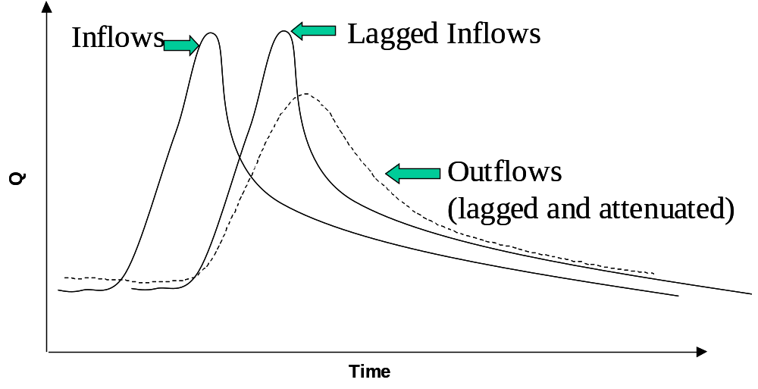
Figure 1: Lag and K Routing
At its fundamental level, the method solves the continuity equation using an approach similar to Muskingum routing (assuming that the Muskingum parameter representing wave storage is negligible). The governing equation for this routing method is given as:

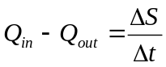

where:

Q_{in} = instantaneous inflow [rate] lagged appropriately,
Q_{out} = instantaneous outflow [rate] lagged appropriately,
ΔS = change in storage in the reach [volume],
Δt = time difference.

The relationship assumes an outflow-storage relationship of the form:
S = k ⋅ Q_{out,}
where:

k = attenuation for the outflow [time].

To ensure accurate results, k should be larger or equal to Δt/2. For discrete time steps these relationships translate into:
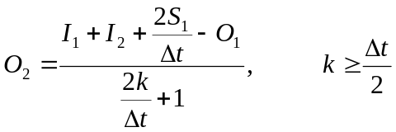
where: I₁ and I₂ are the lagged inflows into the reach at the previous and current time step, respectively,
O₁ and O₂ are the outflows out of the reach at the previous and current time step, respectively,
S₁ is the storage within the reach at the previous time step, defined as S₁ = k⋅O₁, and
Δt is the time difference between the two time steps.

In the case that either I₁ , I₂ or O₁ are missing, these values will be set in the following order:

- Use data from an observed time series (see ObsTSID parameter below).
- Use the nearest value in the input time series (see FillNearest parameter below).
- Use the nearest value in the observed time series (see FillNearest parameter and the ObsTSID parameter below).
- Use a defined default flow value (see DefaultFlow parameter below).

By default, the identifier of the resulting time series is the same as the original input time series, with the data subtype set to “routed” (e.g., Streamflow becomes Streamflow-routed)

The following dialog is used to edit the command and illustrates the syntax for the command (currently only a text-based editor is available and therefore the parameters must be manually entered):

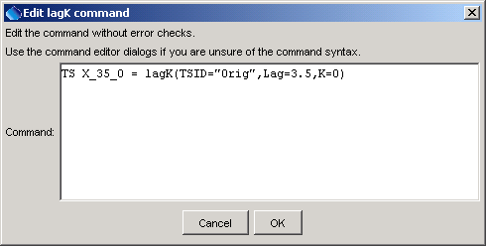
lagK
lagK() Command Editor

Values for Lag and K can usually be established by comparing routed flows to downstream observations. Alternatively, the Lag can be estimated using the reach length and wave speed in the reach. Without any other information, K can be set to Lag/2.

The command syntax is as follows:

TS routed = lagK(param=value,…)

Command Parameters

Parameter | Description | Default
TSID | Identifier or alias for the time series to be routed. It is assumed that this series describes an instantaneous flow. Due to the lagging, the first data values required for the computation of O₂ are not available within this time series and are therefore set to values set in the InflowStates parameter. See also the ObsTSID time series, and the FillNearest and DefaultFlow parameters. | None – must be specified.
ObsTSID | Identifier or alias for an observed time series. If specified, the missing values in the TSID time series will be taken from the observed time series if non-missing. ObsTSID can be used in conjunction with FillNearest to substitute a missing value in the TSID time series with the nearest non-missing value in ObsTSID. | None
FillNearest | If set to True, then when a missing data value is found anywhere in the lagged period, a replacement value will be determined by searching forward and back in time in the input time series to find the nearest non-missing value. The maximum search window depends on the interval of the TSID time series:  - <= Seconds: 1000 intervals  - Minute, Hour: 1 day  - Day: 1 Week  - > Day: 1 interval only  The assumption is that a flow value close in time will be representative of the missing value and will not result in significant errors.  This option has lower precedence than specifying the ObsTSID data. It can also find non-missing data in the ObsTSID if ObsTSID is defined (lower precedence). Both options have a higher precedence than DefaultFlow. | False
DefaultFlow | A flow value in the units of the input time series that is substituted for missing values in the input time series. This has the lowest precedence of all missing data substitutions. It will be applied at any time in the lagged period. | 0
Lag | Lag time for the modeled reach in the units of the TSID time series base interval. For example, if the input time series is 10 minutes, the units of Lag are assumed to be minutes. The Lag value is not required to be evenly divisible by the time step interval; values in the time series between time steps will be linearly interpolated. | Required
K | Attenuation factor to be applied to the wave. The units of K are time, and like the Lag value, it is assumed to have the same units as the input time series. | Required
InflowStates | Comma-delimited list of default inflow values prior to the start of the time series. The order of the values is earliest to latest. The array must specify (Lag/multiplier) + 1 values; i.e., a 10 minute interval with a LAG of 30 must be provided with 30/10 + 1 = 4 inflow carryover values. Note: Specifying values that are not consistent with the Lag and K parameters will result in oscillation! | 0 for each value
OutflowStates | Comma-delimited list of default outflow values prior to the start of the time series. See InflowStates for details. | 0 for each value

A sample commands file is as follows:

TS LKPN6routed = lagK(TSID=LKPN6.USGS.QIN.1HOUR,Lag=3,K=2,FillNearest=true)

