Command Reference: multiply()
Multiply the Data Values in a Time Series by Data Values in Another Time Series
Version 06.08.02, 2004-08-03, Color, Acrobat Distiller

The multiply()command multiplies one time series by another. This is similar to scale() except the multiply() command essentially uses a time series of scale values. Missing data in either time series causes the result to be missing.

The following dialog is used to edit the command and illustrates the syntax of the command. Right clicking on a time series to divide by allows toggling of the TEMPTS key word. This will cause the time series to divide to be read and then discarded, simplifying the input file. However, to insert the time series the first time, the time series must have been listed in the commands file as a time series identifier.

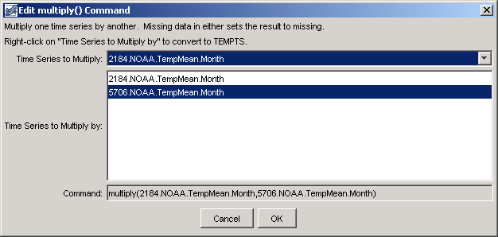
multiply
multiply() Command Editor

The command syntax is as follows:

multiply(TSID,MultiplierTSID)

Command Parameters

Parameter | Description | Default
TSID | The time series identifier or alias for the time series to be modified. Right clicking on a time series to divide by allows toggling of the TEMPTS key word. This will cause the time series to divide to be read and then discarded, simplifying the input file. However, to insert the time series the first time, the time series must have been listed in the commands file as a time series identifier. | None – must be specified.
MultiplierTSID | The time series identifier or alias for the time series that is the multiplier. | None – must be specified.

A sample commands file is as follows (this example does not necessarily make sense – the multiply() command is used for numerical calculations in an analysis):

# 2184 - DEL NORTE 2 E
2184.NOAA.TempMean.Month~HydroBase
# 5706 - MONTE VISTA 2 W
5706.NOAA.TempMean.Month~HydroBase
multiply(2184.NOAA.TempMean.Month,5706.NOAA.TempMean.Month)

