Command Reference: readDateValue()
Read all time series from a DateValue File
Version 06.10.08, 2005-09-22, Color, Acrobat Distiller

The readDateValue() command reads all the time series in a DateValue file into memory (see the DateValue Input Type Appendix). The actual reading occurs as the commands are being processed. Therefore, if any other commands reference the DateValue time series, time series identifiers will need to be specified manually (they are not available to list in dialogs like other time series specified with identifiers) or use wildcards in identifiers.

The following dialog is used to edit the command and illustrates the syntax for the command. The path to the file can be absolute or relative to the working directory. The Browse button can be used to select the file to read (if a relative path is desired, delete the leading path after the select). Use the TS Alias = readDateValue() command to read a single time series from a DateValue file.

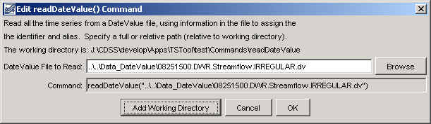
readDateValue
readDateValue() Command Editor

The command syntax is as follows:

readDateValue(InputFile)

Command Parameters

Parameter | Description | Default
InputFile | The name of the DateValue input file to read, surrounded by double quotes. | None – must be specified.

A sample commands file is as follows:

readDateValue("..\..\Data_DateValue\08251500.DWR.Streamflow.IRREGULAR.dv")

This page is intentionally blank.

