Command Reference: readMODSIM()
Read all time series from a MODSIM output file
Version 06.10.08, 2005-09-22, Color, Acrobat Distiller

The readMODSIM() command reads into memory all the time series in a MODSIM output file (see the MODSIM Input Type Appendix). The actual reading occurs as the commands are being processed. Therefore, if any other commands reference the MODSIM time series, the time series identifiers must be specified manually (they are not available to list in dialogs like other time series specified with identifiers) or use wildcards in identifiers. The following dialog is used to edit the command and illustrates the syntax for the command. Use the TS Alias = readMODSIM() command to read a single time series from a MODSIM file.

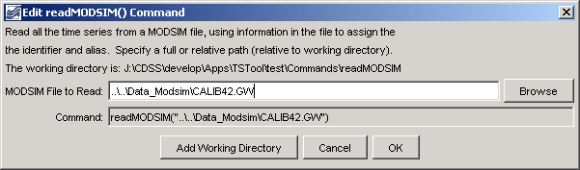
readMODSIM
readMODSIM() Command Editor

The command syntax is as follows:

readMODSIM(InputFile)

Command Parameters

Parameter | Description | Default
InputFile | The name of the MODSIM file to read, surrounded by double quotes. The path to the file can be absolute or relative to the working directory. The Browse button can be used to select the file to read (if a relative path is desired, remove the leading path after the select). | None – must be specified.

A sample commands file is as follows:

readMODSIM("..\..\Data_Modsim\CALIB42.GW")

This page is intentionally blank.

