Command Reference: readNwsCard()
Read all time series from an NWS CARD file
Version 06.14.00, 2006-01-05, Color, Acrobat Distiller

The readNwsCard() command reads all the time series in an NWS CARD file into memory (see the NWSCard Input Type Appendix). The actual reading occurs as the commands are being processed. Therefore, if any other commands reference the NWS Card time series, time series identifiers will need to be specified manually (they are not available to list in dialogs like other time series specified with identifiers) or use wildcards in identifiers. This command can be used to read the single time series format or trace format file.

If a trace file is read, each trace will be identified by the historical year for the start of the trace, and will be available as a time series for other commands.

The following dialog is used to edit the command and illustrates the syntax for the command. The path to the file can be absolute or relative to the working directory. The Browse button can be used to select the file to read (if a relative path is desired, delete the leading path after the select). Use the TS Alias = readNwsCard() command to read a single time series from an NWS Card file.

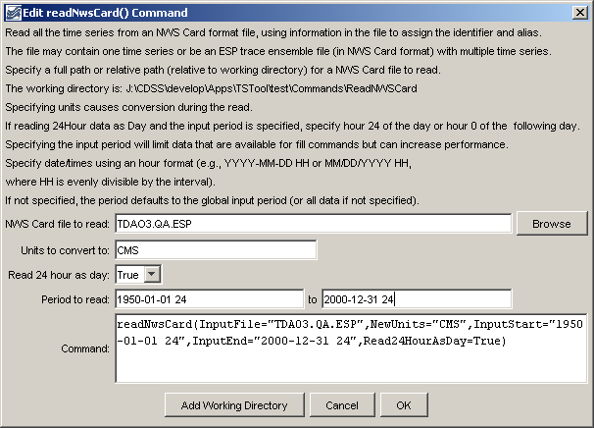
readNwsCard
readNwsCard() Command Editor

The command syntax is as follows:

readNwsCard(param=value,…)

Command Parameters

Parameter | Description | Default
InputFile | The name of the NWS Card input file to read, surrounded by double quotes. | None – must be specified.
NewUnits | The units to convert to after the read. | Do not convert the units.
Read24HourAsDay | If True, read 24Hour time series as if the data were Day interval. Because NWS Card format uses hours 1 to 24, treating as 24Hour results in values being saved at hour zero of the next day. Reading as Day interval causes the values to be stored without the shift. | False – read as hourly and shift data at hour 24 to zero of the next day.
InputStart | The start of the period to read – specify if the read period should be different from the global query period. If Read24HourAsDay=True, specify the period using either hour 24 of the start day, or hour 0 of the next day. This parameter must be specified to hour precision with hour’s aligning with the file’s data. | Use the global input period or if not specified read all the data in the file.
InputEnd | The end of the period to read – specify if the read period should be different from the global query period. If Read24HourAsDay=True, specify the period using either hour 24 of the start day, or hour 0 of the next day. This parameter must be specified to hour precision | Use the global input period or if not specified read all the data in the file.

The following example command reads a file for the specified period, converts the data (from CFS) to CMS, and reads 24Hour data as Day:

readNwsCard(InputFile="TDAO3.QA.ESP",NewUnits="CMS",InputStart="1950-01-01 24",InputEnd="2000-12-31 24",Read24HourAsDay=True)

