Command Reference: TS Alias = readNwsCard()
Read a single time series from a NWS card file
Version 06.14.00, 2006-01-05, Color, Acrobat Distiller

The TS Alias = readNwsCard() command reads a single time series from a NWS Card file (see the NWSCard Input Type Appendix) and assigns an alias to the result. The time series identifier for the time series is set using location = station identifier, data source = blank, data type = data type from file header, and data interval = data interval from file header (or see the Read24HourAsDay parameter below).

The following dialog is used to edit the command and illustrates the syntax.

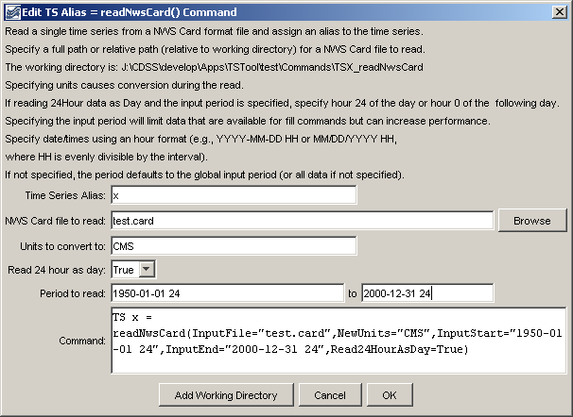
TS_readNwsCard
TS Alias = readNwsCard() Command Editor

The command syntax is as follows:

TS Alias = readNwsCard(param=value,…)

Command Parameters

Parameter | Description | Default
Alias | Alias for the new time series that is read from the file, which can be used instead of the TSID by other commands. | None – must be specified.
InputFile | The name of the NWS Card file to read, surrounded by double quotes. The path to the file can be absolute or relative to the working directory. The Browse button can be used to select the file to read (if a relative path is desired, remove the leading path after the select). | None – must be specified.
NewUnits | The new units for the time series. The data values will be converted to these units. | Do not convert the units.
Read24HourAsDay | If True, read 24Hour time series as if the data were Day interval. Because NWS Card format uses hours 1 to 24, treating as 24Hour results in values being saved at hour zero of the next day. Reading as Day interval causes the values to be stored without the shift. | False – read as hourly and shift data at hour 24 to zero of the next day.
InputStart | The start of the period to read – specify if the read period should be different from the global query period. If Read24HourAsDay=True, specify the period using either hour 24 of the start day, or hour 0 of the next day. This parameter must be specified to hour precision with hour’s aligning with the file’s data. | Use the global input period or if not specified read all the data in the file.
InputEnd | The end of the period to read – specify if the read period should be different from the global query period. If Read24HourAsDay=True, specify the period using either hour 24 of the start day, or hour 0 of the next day. This parameter must be specified to hour precision | Use the global input period or if not specified read all the data in the file.

A sample commands file to read hourly data is as follows:

TS Alias = readNwsCard(InputFile="ts1.QIN.txt")

A sample commands file to read 24Hour data as a daily time series, while converting units, is as follows:

TS x = readNwsCard(InputFile="test.card",NewUnits="CMS",
InputStart="1950-01-01 24",InputEnd="2000-12-31 24",Read24HourAsDay=True)

