Command Reference: TS Alias = readRiverWare()
Read a single time series from a RiverWare file
Version 06.10.08, 2005-09-22, Color, Acrobat Distiller

The TS Alias = readRiverWare() command reads a single time series from a RiverWare file (see the RiverWare Input Type Appendix) and assigns an alias to the result.

The following dialog is used to edit the command and illustrates the command syntax.

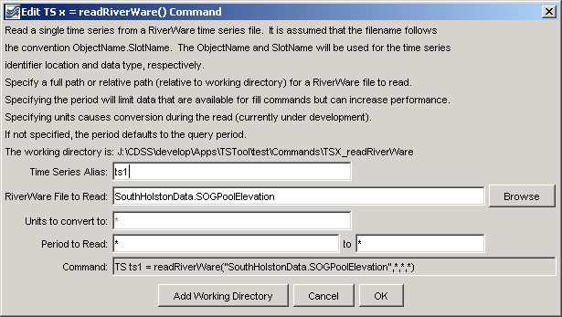
TS_readRiverWare
TS Alias = readRiverWare() Command Editor

The command syntax is as follows:

TS Alias = readRiverWare(InputFile,NewUnits,InputStart,InputEnd)

Command Parameters

Parameter | Description | Default
Alias | Alias for the new time series that is read from the file, which can be used instead of the TSID in other commands. | None – must be specified.
InputFile | The name of the RiverWare file to read, surrounded by double quotes. The path to the file can be absolute or relative to the working directory. The Browse button can be used to select the file to read (if a relative path is desired, remove the leading path after the select). | None – must be specified.
NewUnits | The new units for the time series. The data values will be converted to these units. | Use the units read from the file.
InputStart | The start of the period to read data – specify if the period should be different from the global query period. | Use the global query period.
InputEnd | The end of the period to read data – specify if the period should be different from the global query period. | Use the global query period.

A sample commands file is as follows:

TS ts1 = readRiverWare("SouthHolstonData.SOGPoolElevation","QIN.txt",*,*,*)

