Command Reference: readStateMod()
Read all the time series from a StateMod time series file
Version 06.10.08, 2005-09-22, Color, Acrobat Distiller

The readStateMod() command reads all the time series in a StateMod time series file into memory (see the StateMod Input Type Appendix). The actual reading occurs as the commands are being processed. Therefore, if any other commands reference the StateMod time series, the time series identifiers must be specified manually or use wildcards in identifiers (identifiers are not available to list in dialogs like other time series specified with identifiers). Time series that are read are added to the list of time series (they do not replace time series with matching identifiers).

The following dialog is used to edit the command and illustrates the syntax for the command.

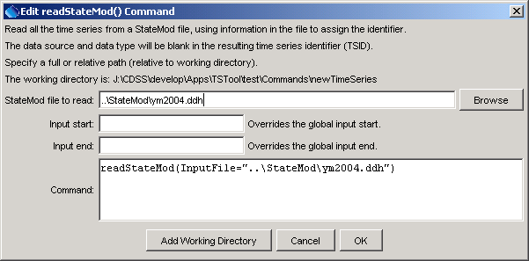
readStateMod
readStateMod() Command Editor

The command syntax is as follows:

readStateMod(param=value,…)

Command Parameters

Parameter | Description | Default
InputFile | The name of the StateMod time series file to read, surrounded by double quotes. The path to the file can be absolute or relative to the working directory. The Browse button can be used to select the file to read (if a relative path is desired, remove the leading path after the select). | None – must be specified.
InputStart | The start of the period to read data – specify if the period should be different from the global query period. | Use the global query period.
InputEnd | The end of the period to read data – specify if the period should be different from the global query period. | Use the global query period.

A sample commands file is as follows:

readStateMod(InputFile="..\StateMod\ym2004.ddh")

