Command Reference: TS X = relativeDiff()
Create a Relative Difference Time Series
Version 06.09.00, 2004-09-14, Color, Acrobat Distiller

A relativeDiff() command can be inserted to create a new relative difference time series, computed by subtracting the time series and then dividing by one of the time series. This is useful when analyzing the relative magnitudes of two time series over time. Most of the properties for the new time series are the same as the first time series. The alias for the result can be referenced by other commands. The following dialog is used to edit the command and illustrates its syntax. The divisor can be either of the time series. The result is set to missing if either time series value is missing or the divisor is zero.

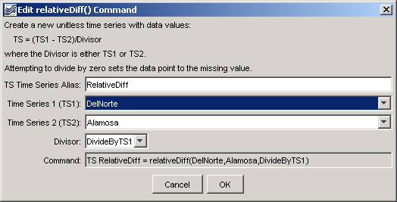
relativeDiff
relativeDiff() Command Editor

The command syntax is as follows:

TS X = relativeDiff(TSID1,TSID2,Divisor)

Command Parameters

Parameter | Description | Default
X | The alias for the new time series. | None – must be specified.
TSID1 | The time series identifier or alias for the first time series. | None – must be specified.
TSID2 | The time series identifier or alias for the second time series (subtracted from the first). | None – must be specified.
Divisor | Indicates whether the first time series is the divisor (DivideByTS1) or the second time series is the divisor (DivideByTS2). | None – must be specified.

A sample commands file is as follows:

setOutputPeriod(01/1912,12/1998)
# (1912-1998) RIO GRANDE AT ALAMOSA, CO. DWR Streamflow Monthly
TS Alamosa = readTimeSeries("08223000.DWR.Streamflow.Month~HydroBase")
# (1890-1998) RIO GRANDE NEAR DEL NORTE, CO. DWR Streamflow Monthly
TS DelNorte = readTimeSeries("08220000.USGS.Streamflow.Month~HydroBase")
TS RelativeDiff = relativeDiff(DelNorte,Alamosa,DivideByTS1)

The input time series for the command are shown in the following figure:

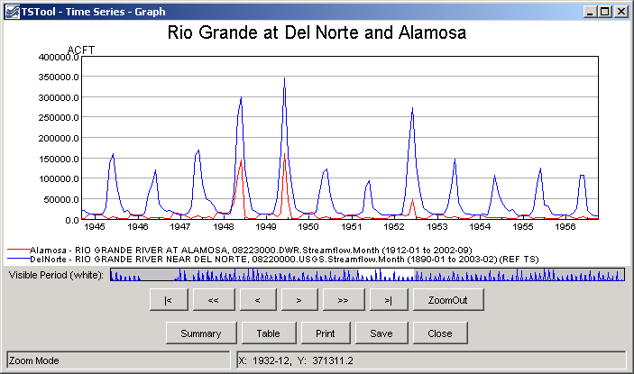
relativeDiff_GraphData
Data for the relativeDiff() Command

The results of processing the commands are shown in the following figure:

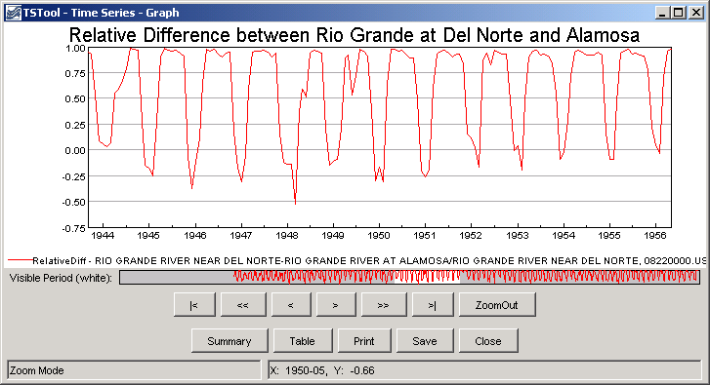
relativeDiff_Graph
Results of the relativeDiff() Command

This page is intentionally blank.

