Command Reference: runProgram()
Run an External Program
Version 06.08.02, 2004-08-03, Color, Acrobat Distiller

To run an external program, insert a runProgram() command. This command will run the given command line and wait until the program is finished before processing additional commands. It is therefore possible to call an external program that reads and/or writes recognized time series formats and can perform some analysis that TSTool cannot. Another use of this command is to create a calibration environment where a model is run and then the results are read and displayed using TSTool. The following dialog is used to edit the command and illustrates the command syntax.

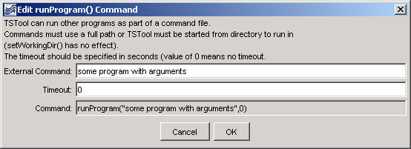
runProgram
runProgram() Command Editor

The command syntax is as follows:

runProgram(CommandLine,Timeout)

Command Parameters

Parameter | Description | Default
CommandLine | The program command line, with arguments. If the program executable is found in the PATH, then only the program name needs to be specified. Otherwise, specify an absolute path to the program or run TSTool from the same directory.  TSTool has no understanding of the external program's command line options. Therefore, it does not try to modify these options to reflect a working directory. It may therefore be necessary to run TSTool from a command prompt (rather from the Start menu) in order for the external program to run correctly. | None – must be specified.
Timeout | The timeout in seconds – if the program has not yet returned, the process will be ended. Zero indicates no timeout. | None – must be specified.

