Command Reference: setAveragePeriod()
Set Period Used to Compute Historical Averages
Version 06.08.02, 2004-08-02, Color, Acrobat Distiller

The setAveragePeriod() command sets the period that is used to compute historic averages used with the fillHistMonthAverage() and fillHistYearAverage() commands. If the averaging period is not specified, the available period is used. Use a setAveragePeriod() command if a subset of the data should be used to compute averages. The following dialog is used to edit this command and illustrates the command syntax.

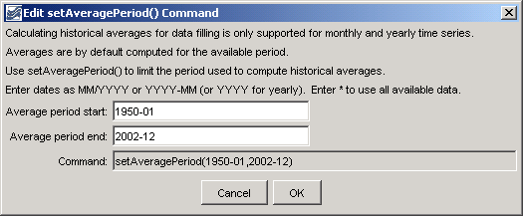
setAveragePeriod
setAveragePeriod() Command Editor

The command syntax is as follows:

setAveragePeriod(AverageStart,AverageEnd)

Command Parameters

Parameter | Description | Default
AverageStart | The date for the start of the averaging period. The precision of the date should agree with that of time series to be processed. | None – must be specified.
AverageEnd | The date for the end of the averaging period. The precision of the date should agree with that of time series to be processed. | None – must be specified.

A sample commands file is as follows:

setAveragePeriod(1950-01,2002-12)

This page is intentionally blank.

