Command Reference: setDebugLevel()
Set Level for Debug Messages
Version 06.08.02, 2004-08-03, Color, Acrobat Distiller

The setDebugLevel() command sets the debug levels for screen and log file diagnostic messages. This command can be used multiple times with different debug level (e.g., to isolate a problem). The following dialog is used to edit this command and illustrates the command syntax.

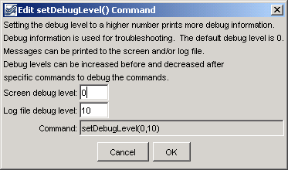
setDebugLevel
setDebugLevel() Command Editor

The command syntax is as follows:

setDebugLevel(ScreenLevel,LogFileLevel)

Command Parameters

Parameter | Description | Default
ScreenLevel | The debug level for the screen (0+). | None – must be specified.
LogFileLevel | The debug level for the log file (0+). | None – must be specified.

A sample commands file is as follows:

setDebugLevel(0,10)

This page is intentionally blank.

