Command Reference: setMax()
Set Data Values to the Maximum of Values from One or More Time Series
Version 06.08.02, 2004-08-02, Color, Acrobat Distiller

The setMax() command sets a time series to contain, for each time step, the maximum of its own values and those of one or more additional time series. The following dialog is used to edit the command and illustrates the command syntax.

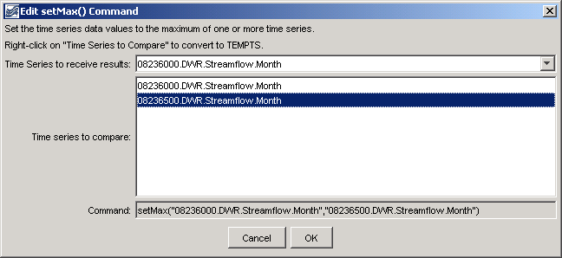
setMax
setMax() Command Editor

The command syntax is as follows:

setMax(TSID,IndependentTSID,IndependentTSID)

Command Parameters

Parameter | Description | Default
TSID | The time series identifier or alias for the time series to be modified. | None – must be specified.
IndependentTSID | The time series identifier or alias for the independent time series, to supply data. Repeat for each time series to be compared. | None – at least one time series identifier or alias must be specified.

A sample commands file is as follows:

# 08236000 - ALAMOSA RIVER ABOVE TERRACE RESERVOIR
08236000.DWR.Streamflow.Month~HydroBase
# 08236500 - ALAMOSA RIVER BELOW TERRACE RESERVOIR
08236500.DWR.Streamflow.Month~HydroBase
setMax("08236000.DWR.Streamflow.Month","08236500.DWR.Streamflow.Month")

