Command Reference: setOutputPeriod()
Set the Output Period for Time Series
Version 06.08.02, 2004-08-03, Color, Acrobat Distiller

The setOutputPeriod() command sets the output period for time series. See also the setQueryPeriod() command. The period for a time series when read or created will be set to the maximum of the following periods, in order to satisfy output and data filling requirements:

- available,
- output (if specified),
- and query (if specified).

Specifying the output period is necessary when creating model files or filling an extended period (time series will not automatically be extended by fill commands). This command replaces the older MM/YYYY syntax. The following dialog is used to edit this command and illustrates the syntax of the command. Note that the output period should always use calendar month and year, even if other than calendar year are used for output (see setOutputYearType()).

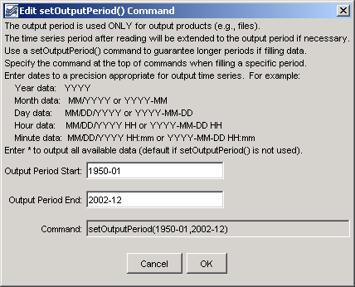
setOutputPeriod
setOutputPeriod() Command Editor

The command syntax is as follows:

setOutputPeriod(OutputStart,OutputEnd)

Command Parameters

Parameter | Description | Default
OutputStart | The date/time to start output. | None – must be specified.
OutputEnd | The date/time to end output. | None – must be specified.

A sample commands file is as follows:

setOutputPeriod(1950-01,2002-12)

