Command Reference: setOutputYearType()
Set the Output Year Type for Time Series
Version 06.08.02, 2004-08-03, Color, Acrobat Distiller

The setOutputYearType() command is used to define the global output year type for output reports and files. This command replaces the older -wy and -cy options. The output year type is recognized by some common tools, including the time series summary and writeStateMod() command. Write commands are being updated to allow the global year type to be reset for the specific command. The following dialog is used to edit the command and illustrates the command syntax.

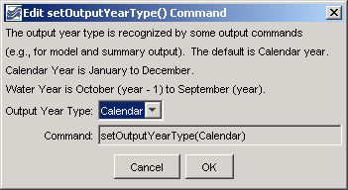
setOutputYearType
setOutputYearType() Command Editor

The command syntax is as follows:

setOutputYearType(OutputYearType)

Command Parameters

Parameter | Description | Default
OutputYearType | The output year type, one of:  - Calendar – January through December.  - Water – October through November.  In the future, more generic types like JanToDec may be implemented. | If this command is not specified, Calendar is the default.

A sample commands file is as follows:

setOutputYearType(Calendar)

This page is intentionally blank.

