Command Reference: setQueryPeriod()
Set the Period for Queries
Version 06.14.00, 2005-12-14, Color, Acrobat Distiller

This command has been replaced by setInputPeriod(). Editing the command with the command editor dialog will convert setQueryPeriod() commands to setInputPeriod().

The setQueryPeriod() command sets the period used for querying and reading time series data, from databases and files. The default is to query all available data so that all data are available for analysis and data filling. However, a shorter period may be desirable to increase performance (e.g., when processing real-time data). See also the setOutputPeriod() command. The following dialog is used to edit the command and illustrates the command syntax.

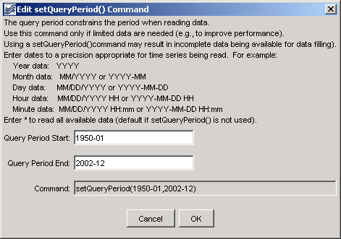
setQueryPeriod
setQueryPeriod() Command Editor

A sample commands file is as follows:

setQueryPeriod(1950-01,2002-12)

This page is intentionally blank.

