Command Reference: setWorkingDir()
Set Working Directory
Version 06.10.08, 2005-09-22, Color, Acrobat Distiller

This command should not be used in most cases.

The setWorkingDir() command is used to define the working directory for a set of commands. The working directory, when set properly, can greatly simplify commands files because relative file paths can be used for input and output. The working directory is normally set in one of the following ways, with the current setting being defined by the most recent item that has occurred:

- The startup directory for the TSTool program,
- The directory where a commands file was opened,
- The directory where a commands file was saved,
- The directory specified by a setWorkingDir() command,
- The directory specified by File…Set Working Directory.

In most cases, a setWorkingDir() command is not needed and should be avoided because it complicates commands. However, for complicated commands files, it may be necessary to change the working directory from one directory to another during processing. Setting the working directory to an absolute path causes all relative paths for input and output files to be appended to the working directory. The following dialog is used to edit the command and illustrates the syntax of the command.

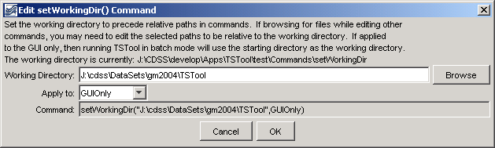
setWorkingDir
setWorkingDir() Command Editor

The command syntax is as follows:

setWorkingDir(WorkingDir,SetWhen)

Command Parameters

Parameter | Description | Default
WorkingDir | The working directory that should be used. The Browse button allows you to select the working directory (it is limited to selecting a file in the directory, but only the directory is used in the command).  Currently the working directory cannot be a relative path like “..”, but this capability may be added in the future. | None – must be specified.
RunMode | The values of the Apply To field can be GUIOnly (the command applies only to the GUI) or GUIAndBatch (the command applies to GUI and batch runs). The former is useful because a commands file can be constructed that uses all relative paths and the setWorkingDir() command will tell the GUI where to find files but the batch run will be relative to the directory where it is run. | None – must be specified.

A sample commands file is as follows:

setWorkingDir("J:\cdss\DataSets\gm2004\TSTool",GUIOnly)

