Command Reference: subtract()
Subtract One or More Time Series From Another Time Series
Version 06.10.00, 2005-02-23, Color, Acrobat Distiller

The subtract() command subtracts time series of the same interval. The receiving time series will have data values set to its original values minus the data values in the indicated time series. This command replaces the older subtract() command, which did not have the flag indicating how to handle missing data.

This command will generate an error if the time series do not have compatible units. If the units are compatible but are not the same (e.g., IN and FT), then the units of the part will be converted to the units of the result before subtraction. Missing data in the parts can be ignored (do not set the result to missing) or can set missing values in the result. The user should consider the implications of ignoring missing data. Time series being subtracted must have the same data interval.

The following dialog is used to edit the command and illustrates the syntax of the command.

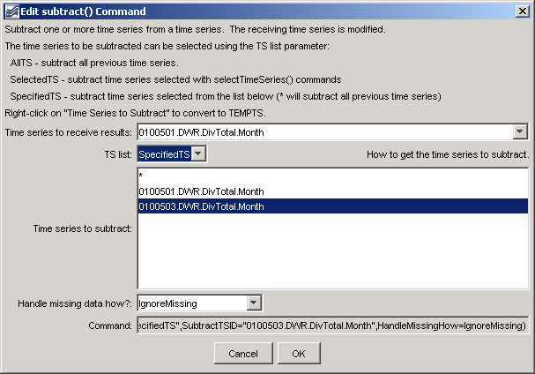
subtract
subtract() Command Editor

The command syntax is as follows:

subtract(param=value,…)

Command Parameters

Parameter | Description | Default
TSID | The time series identifier or alias for the time series to receive the result. | None – must be specified.
TSList | Indicates how the list of time series is specified, one of:  - AllTS – all time series prior to the command.  - SelectedTS – the time series are those selected with the selectTimeSeries() command.  - SpecifiedTS – the specified list of time series given by the SubtractTSID parameter. | AllTS
SubtractTSID | If the TSList parameter is SpecifiedTS, provide the list of time series identifiers (or alias) to subtract. Right clicking on a time series allows toggling of the TEMPTS key word. This will cause the time series to subtract to be read and then discarded. | Must be specified if TSList=SpecifiedTS, ignored otherwise.
HandleMissingHow | Indicates how to handle missing data in a time series, one of:  - IgnoreMissing – create a result even if missing data are encountered in one or more time series – this option is not as rigorous as the others  - SetMissingIfOtherMissing – set the result missing if any of the other time series values is missing  - SetMissingIfAnyMissing – set the result missing if any time series value involved is missing | IgnoreMissing

A sample commands file is as follows:

# 0100501 - EMPIRE DITCH
0100501.DWR.DivTotal.Month~HydroBase
# 0100503 - RIVERSIDE CANAL
0100503.DWR.DivTotal.Month~HydroBase
subtract(TSID="0100501.DWR.DivTotal.Month",TSList="SpecifiedTS",
SubtractTSID="0100503.DWR.DivTotal.Month",HandleMissingHow=IgnoreMissing)

