Command Reference: TS X = weightTraces()
Create a Time Series by Weighting Data from Time Series Traces
Version 06.08.02, 2004-07-29, Color, Acrobat Distiller

The weightTraces() command creates a new time series as a weighted sum of time series traces, which were produced by a createTraces() command. The following dialog is used to edit the command and illustrates the syntax of the command. Most often when using this command you will have interactively reviewed available traces to decide which traces should be weighted.

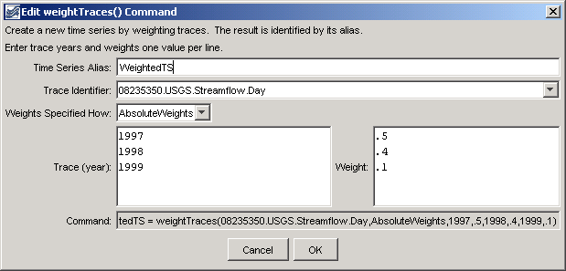
TS_weightTraces
weightTraces() Command Editor

The command syntax is as follows:

TS X = weightTraces(TSID,SpecifWeightsHow,Year,Weight,…)

Command Parameters

Parameter | Description | Default
X | The alias of the new time series. | None – must be specified.
TSID | The time series identifier or alias for a time series that has been converted into traces (e.g., from a createTraces() command). Time series matching the identifier will be checked. | None – must be specified.
SpecifyWeightsHow | Weights are currently only applied as AbsoluteWeights (in the future an option may be added to normalized weights to 1.0 accounting for missing data in the traces). | Must be AbsoluteWeights.
Year,Weight | Specify pairs of trace year and weights (0-1.0), used to create the new time series. Trace years must be manually entered because at the time that the command is edited, time series have not yet been queried. | None – must be specified.

A sample commands file is as follows:

# Create annual traces from a time series shifted to the current year
#
# (1995-1998) ALAMOSA RIVER ABOVE JASPER, CO USGS Streamflow Day
08235350.USGS.Streamflow.Day~HydroBase
createTraces(08235350.USGS.Streamflow.Day,1Year,2004-01-01,ShiftToReference)
TS WeightedTS =
weightTraces(08235350.USGS.Streamflow.Day,AbsoluteWeights,1997,.5,1998,.4,1999,.1)

The results from the commands are shown in the following graph:

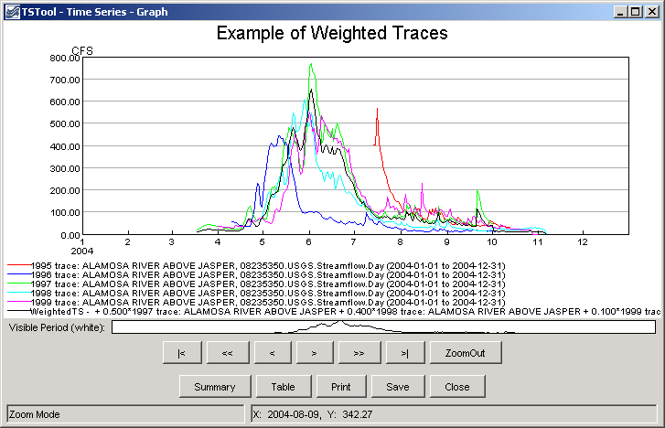
TS_weighTraces_Graph
Results of the weightTraces() Command

This page is intentionally blank.

