Command Reference: writeNwsCard()
Write Time Series to NWS Card Format File
Version 06.08.02, 2004-08-03, Color, Acrobat Distiller

The writeNwsCard() command writes the first time series to the specified NWS Card format file. See the NWSCard Input Type Appendix for more information about the file format. Only daily or hourly time series can be written. The following dialog is used to edit the command and illustrates the syntax of the command.

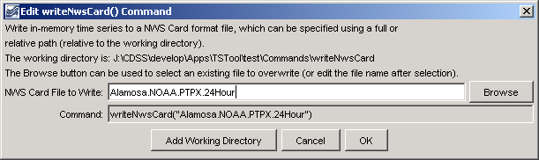
writeNwsCard
writeNwsCard() Command Editor

The command syntax is as follows:

writeNwsCard(OutputFile)

Command Parameters

Parameter | Description | Default
OutputFile | The NWS Card output file to write. The path to the file can be absolute or relative to the working directory. The Browse button can be used to select the file to write (if a relative path is desired, delete the leading path after the select). | None – must be specified.

A sample commands file is as follows:

# 0130 - ALAMOSA SAN LUIS VALLEY RGNL
0130.NOAA.Precip.Day~HydroBase
writeNwsCard("Alamosa.NOAA.PTPX.24Hour")

This page is intentionally blank.

