Command Reference: writeRiverWare()
Write Time Series to a RiverWare Format File
Version 06.10.06, 2005-08-04, Color, Acrobat Distiller

The writeRiverWare() command writes the first time series in memory to the specified RiverWare format file. See the RiverWare Input Type Appendix for more information about the file format.

The following dialog is used to edit the command and illustrates the syntax of the command.

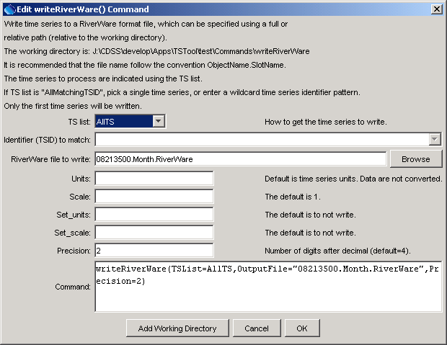
writeRiverWare
writeRiverWare() Command Editor

The command syntax is as follows:

writeRiverWare(param=value, …)

Command Parameters

Parameter | Description | Default
TSList | Indicate how to determine the list of time series to process, one of:  - AllMatchingTSID – process time series that have identifiers matching the TSID parameter.  - AllTS – process all the time series.  - SelectedTS – process the time series that are selected (see selectTimeSeries()). | None – must be specified.
TSID | Used if TSList=AllMatchingTSID to indicate the time series identifier or alias for the time series to be filled. Specify * to match all time series or use a wildcard for one or more identifier parts. | Required if TSList=AllMatchingTSID.
OutputFile | The RiverWare file to write. The path to the file can be absolute or relative to the working directory. The Browse button can be used to select the file to write (if a relative path is desired, delete the leading path after the select). | None – must be specified.
Units | The data units to be output. Specify units that are recognized by RiverWare – the units are not actually converted but the new units string is used in the output file. | Use the units in the time series.
Scale | See the RiverWare Input Type Appendix. | 1
Set_units | See the RiverWare Input Type Appendix. | Set_units are not output.
Set_scale | See the RiverWare Input Type Appendix. | Set_scale are not output.
Precision | The number of digits after the decimal to write. | 4

A sample commands file is as follows:

# 08213500 - RIO GRANDE RIVER AT THIRTY MILE BRIDGE NEAR CREEDE
08213500.DWR.Streamflow.Month~HydroBase
writeRiverWare(TSList=AllTS,OutputFile="08213500.Month.RiverWare",Precision=2)

