Command Reference: writeStateMod()
Write Time Series to a StateMod Format File
Version 06.17.00, 2006-05-01, Color, Acrobat Distiller

The writeStateMod() command writes the time series in memory to the specified StateMod format file. See the StateMod Input Type Appendix for more information about the file format. It is expected that the time series have the same interval. The time series identifier location part is written as the identifier, even if an alias is assigned to a time series.

The following dialog is used to edit the command and illustrates the syntax of the command.

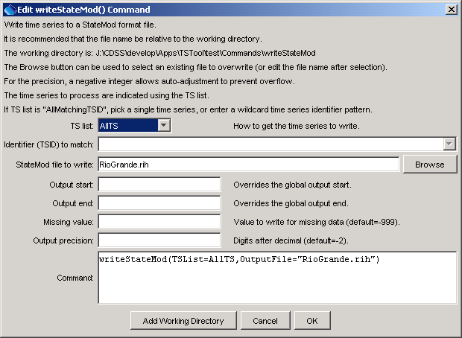
writeStateMod
writeStateMod() Command Editor

The command syntax is as follows:

writeStateMod(param=value,…)

Command Parameters

Parameter | Description | Default
TSList | Indicate how to determine the list of time series to process, one of:  - AllMatchingTSID – process time series that have identifiers matching the TSID parameter.  - AllTS – process all the time series.  - SelectedTS – process the time series that are selected (see selectTimeSeries()). | None – must be specified.
TSID | Used if TSList=AllMatchingTSID to indicate the time series identifier or alias for the time series to be filled. Specify * to match all time series or use a wildcard for one or more identifier parts. | Required if TSList=AllMatchingTSID.
OutputFile | The StateMod file to write. The path to the file can be absolute or relative to the working directory. The Browse button can be used to select the file to write (if a relative path is desired, delete the leading path after the select). | None – must be specified.
OutputStart | The date/time for the start of the output. | Use the global output period.
OutputEnd | The date/time for the end of the output. | Use the global output period.
MissingValue | The value to write for missing data. | -999
Precision | The number of digits to use after the decimal point, for data values. A negative number indicates that if the formatted number is larger than the allowed output width, adjust the format accordingly by truncating fractional digits. A special value of –2001 is equivalent to –2 and additionally NO decimal point will be printed for large values. | The default output precision if not specified is -2, which is then reset based on the data units (see the system\DATAUNIT file).

A sample commands file is as follows:

setOutputPeriod(1950-01,2002-12)
# 08213500 - RIO GRANDE RIVER AT THIRTY MILE BRIDGE NEAR CREEDE
08213500.DWR.Streamflow.Month~HydroBase
# 08217000 - RIO GRANDE AT WASON, BELOW CREEDE, CO.
08217000.USGS.Streamflow.Month~HydroBase
writeStateMod(TSList=AllTS,OutputFile="RioGrande.rih")

