Command Reference: writeSummary()
Write Time Series to a Summary Format File
Version 06.08.02, 2004-08-03, Color, Acrobat Distiller

The writeSummary() command writes the time series in memory to a summary report file. The format of the file is a default for the data interval. The following dialog is used to edit the command and illustrates the syntax of the command.

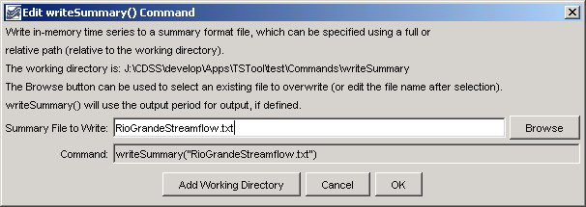
writeSummary
writeSummary() Command Editor

The command syntax is as follows:

writeSummary(OutputFile)

Command Parameters

Parameter | Description | Default
OutputFile | The summary file. The path to the file can be absolute or relative to the working directory. The Browse button can be used to select the file to write (if a relative path is desired, delete the leading path after the select). | None – must be specified.

A sample commands file is as follows:

setOutputPeriod(1950-01,2002-12)
# 08213500 - RIO GRANDE RIVER AT THIRTY MILE BRIDGE NEAR CREEDE
08213500.DWR.Streamflow.Month~HydroBase
# 08217000 - RIO GRANDE AT WASON, BELOW CREEDE, CO.
08217000.USGS.Streamflow.Month~HydroBase
writeSummary("RioGrandeStreamflow.txt")

This page is intentionally blank.

