Command Reference: ReadTableFromDelimitedFile()
Read a table from a delimited file
Version 09.04.00, 2009-06-16

The ReadTableFromDelimitedFile() command reads a table from a comma-delimited file. Table files have the following characteristics:

- Comments indicated by lines starting with # are stripped during the read.
- Extraneous non-data lines in the file can be skipped during the read using the SkipLines parameter.
- Column headings indicated by “quoted” values in the first non-comment line will be used to assign string names to the columns. If no quoted values are present, columns will not have headings.
- Data in columns are assumed to be of consistent type (i.e., all numerical data or all text), based on rows after the header.
- Once read, row numbers (1+) can be referenced by other commands.

Tables are used by other commands when performing lookups of information or generating summary information from processing.

The following dialog is used to edit the command and illustrates the syntax for the command.

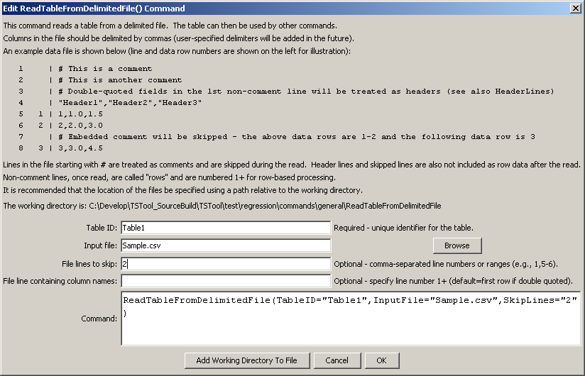
ReadTableFromDelimitedFile
ReadTableFromDelimitedFile() Command Editor
The command syntax is as follows:

ReadTableFromDelimitedFile(Parameter=Value,…)

Command Parameters

Parameter | Description | Default
TableID | Identifier to assign to the table that is read, which allows the table data to be used with other commands. | None – must be specified.
InputFile | The name of the file to read, as an absolute path or relative to the command file location. | None – must be specified.
SkipLines | Indicates the number of lines in the file to skip, which otherwise would interfere with reading row data. Individual row numbers and ranges can be specified, for example: 1,5-6,17 | No lines are skipped.
HeaderLines | Indicate the rows that include header information, which should be used for column names. Currently this should only be one row, although a range may be fully supported in the future. | If the first non-comment line contains quoted field names, they are assumed to be headers. Otherwise, no headers are read.

The following example command file illustrates how to read a table from a delimited file:

ReadTableFromDelimitedFile(TableID="Table1",
InputFile="Sample.csv",SkipRows="2")

An excerpt from a simple delimited file is:

# A comment
some junk to be skipped
“Header1”,”Header2”,”Header3”
1,1.0,1.0
2,2.0,1.5
3,3.0,2.0

