Command Reference: Multiply()
Multiply the data values in a time series by data values in another time series
Version 08.16.04, 2008-09-24

The Multiply()command multiplies one time series by another. Missing data in either time series causes the result to be missing. See also the Scale() command, which multiplies time series by a numerical value.

The following dialog is used to edit the command and illustrates the syntax of the command.

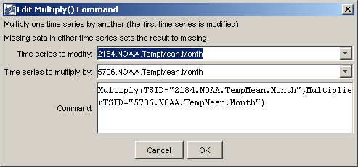
Multiply
Multiply() Command Editor

The command syntax is as follows:

Multiply(Parameter=Value,…)

Command Parameters

Parameter | Description | Default
TSID | The time series identifier or alias for the time series to be modified. | None – must be specified.
MultiplierTSID | The time series identifier or alias for the time series that is the multiplier. | None – must be specified.

A sample command file is as follows (this example does not necessarily make sense but illustrates how the Multiply() command can be used for numerical calculations in an analysis):

# 2184 - DEL NORTE 2 E
2184.NOAA.TempMean.Month~HydroBase
# 5706 - MONTE VISTA 2 W
5706.NOAA.TempMean.Month~HydroBase
Multiply(TSID="2184.NOAA.TempMean.Month",
MultiplierTSID="5706.NOAA.TempMean.Month")

