Command Reference: OpenCheckFile()
Open a check file
Version 08.16.03, 2008-08-21

The OpenCheckFile() command opens an HTML check file, which is intended to provide a summary of results, in contrast to other feedback features:

- the log file provides a sequential and at times highly-detailed list of information, warning, and optionally debug messages that help troubleshoot processing errors; however, it is often not suitable for end users
- the interactive graphical icons that indicate problems with commands focus on commands and the processing sequence; however, even if all commands run there may be problems with results
- the check file checks the results, providing various tabular lists of issues

This command should be inserted near the top of commands, in order to accumulate checks generated during processing. The information is formatted when command processing is complete and the file can be viewed as results.

A useful standard is to name the check file the same as the command file, with an additional _check.html extension. A date or date/time can optionally be added to the check file name.

The following dialog is used to edit the command and illustrates the syntax for the command.

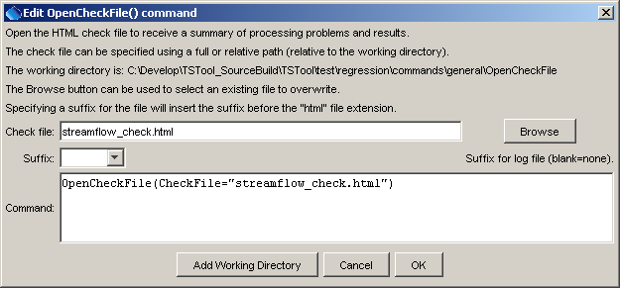
OpenCheckFile
OpenCheckFile() Command Editor

The command syntax is as follows:

OpenCheckFile(Parameter=Value,…)

Command Parameters

Parameter | Description | Default
CheckFile | The name of the check file to write surrounded by double quotes. The extension of .html will automatically be added if not specified. | None – must be specified.
Suffix | Indicates that a suffix will be added before the .html extension, one of:  - Date – add a date suffix of the form YYYYMMDD.  - DateTime – add a date/time suffix of the form YYYYMMDD_HHMMSS.  This is useful for automatically archiving check files corresponding to command files, to allow checking the output at a later time. However, date/time stamping the files may use a lot of disk space for repeated processes. | Do not add the suffix.

A sample command file to open a check file is as follows:

OpenCheckFile(CheckFile="streamflow_check.html")
Example_OpenCheckFile

