Command Reference: */
Comment block end
Version 08.17.00, 2008-10-01

The */ command ends a multi-line comment block and is useful for inserting long comments or temporarily commenting out blocks of commands. See also the /* and # commands. Commands between the /* and */ are not converted to comments but are skipped during processing.

The following dialog is used to edit the command and illustrates the command syntax:

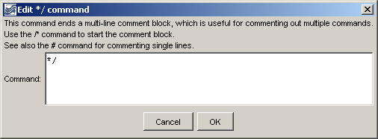
CommentBlockEnd
*/ Command Editor

The command syntax is as follows:

*/

A sample command file is as follows:

/*
SomeCommentedOutCommands()…
*/

This page is intentionally blank.

