Command Reference: Time Series Identifier (TSID)
Read a single time series given the time series identifier
Version 08.17.00, 2008-10-01

A time series identifier (TSID) command reads a single time series. In order to read the time series from a persistent format (database, file, or web site), the TSID must contain the input type, and if necessary, the input name. For example, a TSID command for the State of Colorado’s StateMod model file format is of the form:

LocationID…Interval~StateMod~Filename

Refer to the StateMod Input Type appendix for a full description of the file format. Appendices are available for all input types. A TSID command for a StateMod file is generated as follows:

- Select the StateMod input type and appropriate time step in the main TSTool window.
- Press the Get Time Series List button to list time series. A dialog will prompt for the StateMod file and after selection the first year of data from the file will be read to get a list of identifiers. The interval that is specified (Month or Day) indicates whether the file is a monthly or daily format. The time series will be listed in the time series list in TSTool.
- Select one or more time series from the list and copy to commands.

The following dialog is used to edit the command and illustrates the syntax of the command. Limited checks are done while editing the command. However, once committed, TSTool will attempt to read the time series metadata and will issue a warning if unable to read the data. There is currently no way to automatically convert an absolute path to a relative path; therefore, use the command editor to adjust the path from absolute to relative, if appropriate.

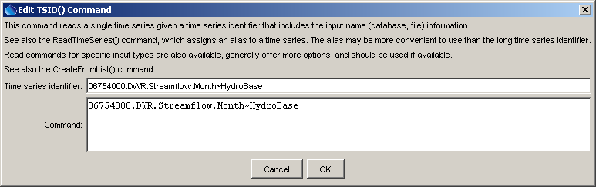
TSID
TSID Command Editor

After executing the command, the time series will have the identifier as originally requested, with no alias being assigned. Use the TS Alias = ReadTimeSeries() command to assign an alias to the time series, or use one of the specific read commands.
A sample command file to read time series from a StateMod file is as follows. In this case the absolute paths have been adjusted to relative paths using the command editor dialog. Note also that the data source and data type are not required because this information is not stored in the StateMod file.

09303000...MONTH~StateMod~whiteT.rih
09303400...MONTH~StateMod~whiteT.rih

A sample command file to read time series from the State of Colorado’s HydroBase database is as follows:

# 06754000 - SOUTH PLATTE RIVER NEAR KERSEY
06754000.DWR.Streamflow.Month~HydroBase
# 06758500 - SOUTH PLATTE RIVER NEAR WELDONA
06758500.DWR.Streamflow.Month~HydroBase

