Command Reference: ReadStateModB()
Read time series from a StateMod binary output time series file
Version 08.17.02, 2008-10-28

The ReadStateModB() command reads time series from a StateMod binary output time series file (see the StateModB Input Type Appendix). Due to the large number of time series that may be read, the time series are only read during processing. Therefore, if any other commands reference the StateMod binary file time series, the time series identifiers must be specified manually or use wildcards in identifiers (identifiers are not available to list in dialogs).

The following dialog is used to edit the command and illustrates the syntax for the command.

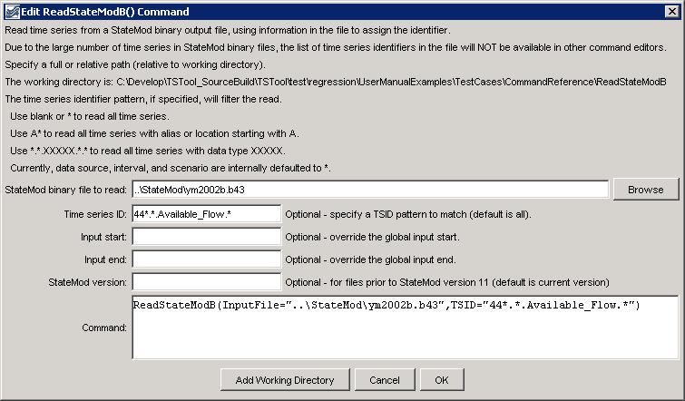
ReadStateModB
ReadStateModB() Command Editor

The command syntax is as follows:

ReadStateModB(Parameter=Value,…)

Command Parameters

Parameter | Description | Default
InputFile | The name of the StateMod binary time series file to read, surrounded by double quotes. The path to the file can be absolute or relative to the working directory. | None – must be specified.
TSID | Time series identifier pattern to filter the read. | Read all time series.
InputStart | The starting date/time to read data, specified to Day or Month precision based on whether a daily or monthly model run. | Read all data.
InputEnd | The ending date/time to read data, specified to Day or Month precision based on whether a daily or monthly model run. | Read all data.
Version | StateMod version number corresponding to the file, necessary because the file version number (and consequently parameters) cannot be automatically detected in older versions. Changes in binary file format occurred with version 9.01 and 9.69, mainly to add new data types. The StateMod file version for version 11+ is automatically detected. | Detect from the file if possible.

The following example command file illustrates how to read all Available_Flow time series for identifiers starting with 44 (e.g., to extract all such time series for a water district):

ReadStateModB(InputFile="..\StateMod\ym2002b.b43",TSID="44*.*.Available_Flow.*")

The following example illustrates how to read all time series from a binary file that was created with StateMod version 9.53. As shown in the example, debug can be turned on for the log file to evaluate issues with the file format.

StartLog(LogFile="commands.TSTool.log")
SetDebugLevel(0,1)
ReadStateModB(InputFile="COLOFB.B43",Version="9.53")

