Command Reference: WriteCheckFile()
Write a check file containing a summary of data/processing problems
Version 09.03.04, 2009-04-23

The WriteCheckFile() command summarizes the results of command processing warning/failure messages in a “check file”. This file is useful for reviewing results and for quality control. The check file is essentially a persistent record of any problems that occurred during processing, whereas a full log file contains a sequential list of processing.

The following dialog is used to edit the command and illustrates the syntax for the command.

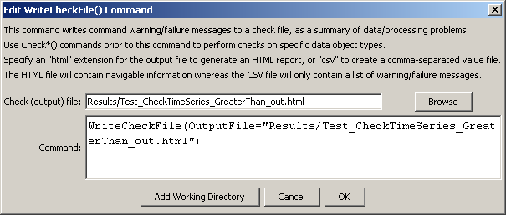
WriteCheckFile
WriteCheckFile() Command Editor

The command syntax is as follows:

WriteCheckFile(Parameter=Value,…)

Command Parameters

Parameter | Description | Default
OutputFile | The name of the check file to create, enclosed in double quotes if the file contains spaces or other special characters. A path relative to the command file containing this command can be specified.  Specify a filename with .html extension to generate an HTML file or .csv to generate a comma-separated value file suitable for use with Excel. The HTML file will contain more information and include navigation links. | None – must be specified.

This page is intentionally blank.

