Command Reference: AppendFile()
Append 1+ files to another file
Version 10.12.00, 2012-07-22

The AppendFile() command appends one or more files to another file. All or only matching lines from input files can be transferred. This command is useful for appending multiple data files into a single file that can be read by TSTool.

The following dialog is used to edit the command and illustrates the syntax for the command.

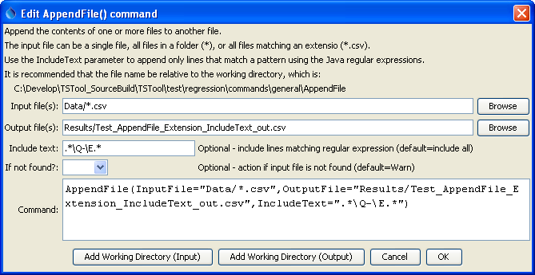
AppendFile
AppendFile() Command Editor

The command syntax is as follows:

AppendFile(Parameter=Value,…)

Command Parameters

Parameter | Description | Default
InputFile | The name of one or more files to delete, using the following conventions:  - No * in name – match one file.  - Filename of *– match all files in input directory (working directory by default).  - Filename of *.ext – match all files with extension  More options may be supported in the future. | None – must be specified.
OutputFile | The output file that will be appended to. The file is created if it does not exist. Use the RemoveFile() command to remove the old file. | None – must be specified.
IncludeText | A regular expression pattern to include text. This uses the Java regular expressions syntax (see http://en.wikipedia.org/wiki/Regular_expression). | Transfer all lines.
IfNotFound | Indicate action if the file is not found, one of:  - Ignore – ignore the missing file (do not warn).  - Warn – generate a warning (use this if the file truly is expected and a missing file is a cause for concern).  - Fail – generate a failure (use this if the file truly is expected and a missing file is a cause for concern). | Warn

The following table lists regular expression examples:

InputText Regular Expression | Description
.*\Q-\E.* | Match lines that start with any character, end with any character, and contain a dash. The \Q and \E characters are special characters to start and end a quoted character, and are necessary because the dash has special meaning in a regular expression.

