Command Reference: TS Alias = NewStatisticTimeSeriesFromEnsemble()
Create a time series containing a statistic determined from a time series ensemble
Version 09.05.01, 2009-10-26

The TS Alias = NewStatisticTimeSeriesFromEnsemble() command uses data from time series in an ensemble to calculate a statistic for each interval in the ensemble, and assigns the statistic value to the corresponding interval in the result. For example, for a statistic of Mean applied to a daily time series, all January 1, 1970 values will be used for the sample and the mean value will be assigned to January 1, 1970 in the output time series. Leap year values will be included if they are included in the period of the ensemble.

The following dialog is used to edit the command and illustrates the syntax for the command.

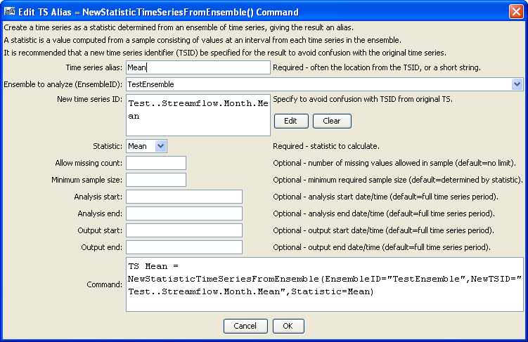
NewStatisticTimeSeriesFromEnsemble
TS Alias = NewStatisticTimeSeriesFromEnsemble() Command Editor

The command syntax is as follows:

TS Alias = NewStatisticTimeSeriesFromEnsemble(Parameter=Value,…)

Command Parameters

Parameter | Description | Default
Alias | The alias of the new time series, which can be used instead of the TSID in other commands. | None – must be specified.
EnsembleID | The identifier for the ensemble to analyze. | None – must be specified.
NewTSID | The time series identifier to be assigned to the new time series, which is useful to avoid confusion with the original time series. This parameter may be required in the future. | None – use the same identifier as the original time series.
Statistic | The statistic to compute. See the Available Statistics table below. | None – must be specified.
Allow  Missing  Count | The number of missing values allowed in the sample of values in order to produce a result. This capability should be used with care because it may result in data that are not representative of actual conditions. | Missing values are ignored in the sample used to compute the statistic.
MinimumSample Size | The minimum number of values in the sample that are required to compute the statistic. | Use the sample with no restrictions, although some statistics may have requirements.
AnalysisStart | The date/time for the analysis start, using a precision that matches the original time series. | Analyze the full period.
AnalysisEnd | The date/time for the analysis start, using a precision that matches the original time series. | Analyze the full period.
OutputStart | The date/time for the output start, using a precision that matches the original time series. An output period longer than the analysis period will result in missing values in output. | Output the full period.
OutputEnd | The date/time for the output start, using a precision that matches the original time series. An output period longer than the analysis period will result in missing values in output. | Output the full period.

Available Statistics

Statistic | Description | Limitations
Max | Maximum of all values in the sample. | None.
Mean | Mean of all values in the sample. | None.
Median | Median of all values in the sample. | None.
Min | Minimum of all values in the sample. | None.

Examples

The following example command file illustrates how to compute the mean statistic for one monthly data:

# Test computing a statistic time series for Month data where Statistic=Mean
StartLog(LogFile="Results/Test_NewStatisticTimeSeriesFromEnsemble_Month_Mean.TSTool.log")
# Define 2 years of data that when averaged equal even numbers
# The 2nd time series is shifted by 1 from the first.
# Include missing values in the first time series but not the second.
TS ts1 = NewPatternTimeSeries(NewTSID="ts1..Streamflow.Month",Description="test data 1",
SetStart="2000-01",SetEnd="2001-12",Units="CFS",
PatternValues=".5,1.5,,3.5,4.5,5.5,6.5,7.5,8.5,9.5,10.5,11.5,
1.5,2.5,3.5,4.5,5.5,6.5,7.5,8.5,9.5,10.5,11.5,12.5")
TS ts2 = NewPatternTimeSeries(NewTSID="ts2..Streamflow.Month",Description="test data 2",
SetStart="2000-01",SetEnd="2001-12",Units="CFS",
PatternValues="1.5,2.5,3.5,4.5,5.5,6.5,7.5,8.5,9.5,10.5,11.5,12.5,
2.5,3.5,4.5,5.5,6.5,7.5,8.5,9.5,10.5,11.5,12.5,13.5")
# Create an ensemble to hold the above time series
NewEnsemble(TSList=AllTS,NewEnsembleID="TestEnsemble",NewEnsembleName="Test Ensemble")
# Compute the statistic
TS Mean = NewStatisticTimeSeriesFromEnsemble(EnsembleID="TestEnsemble",
NewTSID="Test..Streamflow.Month.Mean",
Statistic=Mean)

The following figure illustrates the results:

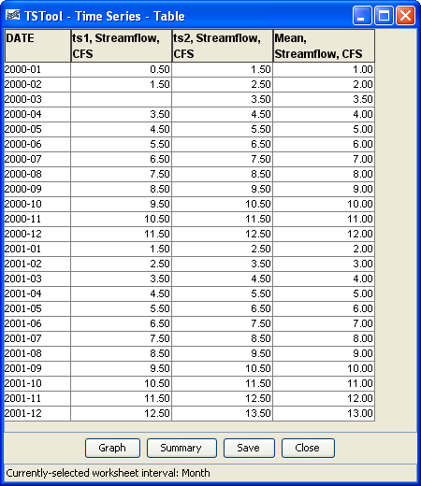
NewStatisticTimeSeriesFromEnsemble_Table
NewStatisticTimeSeriesFromEnsemble() Command Results

