Command Reference: DeselectTimeSeries()
Deselect time series
Version 08.16.00, 2008-07-07

The DeselectTimeSeries() command deselects output time series, as if done interactively, to indicate which time series SHOULD NOT be operated on by following commands. The command minimizes the need for the free() command when used in conjunction with other commands that use a time series list based on selected time series (TSList=SelectedTS). See also the SelectTimeSeries() command.

The following dialog is used to edit the command and illustrates the command syntax.

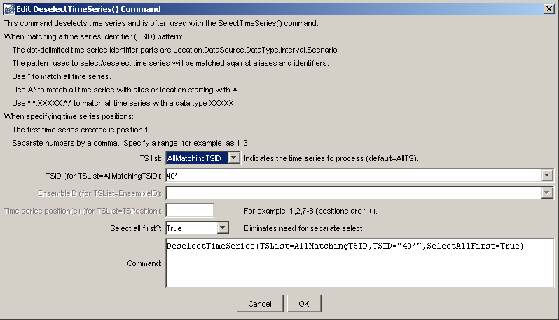
DeselectTimeSeries
DeselectTimeSeries() Command Editor

The command syntax is as follows:

DeselectTimeSeries(Parameter=Value,…)

Command Parameters

Parameter | Description | Default
TSList | Indicates the list of time series to be processed, one of:  - AllMatchingTSID – all time series that match the TSID (single TSID or TSID with wildcards) will be modified.  - AllTS – all time series before the command.  - EnsembleID – all time series in the ensemble will be modified.  - LastMatchingTSID – the last time series that matches the TSID (single TSID or TSID with wildcards) will be modified.  - TSPosition – time series specified by position in the results list (see TSPosition parameter below). | AllTS
TSID | The time series identifier or alias for the time series to be modified, using the * wildcard character to match multiple time series. | TSID or EnsembleID must be specified if identifiers are being matched.
EnsembleID | The ensemble to be modified, if processing an ensemble. | TSID or EnsembleID must be specified if identifiers are being matched.
TSPosition | A list of time series positions in output (1+), separated by commas. | Required if TSList=TSPosition.
SelectAllFirst | Indicates whether all time series should be selected before deselecting the specified time series: True or False. | False

A sample command file is as follows:

TS 401234 = NewPatternTimeSeries(NewTSID="401234..Precip.Day",
Description="Example data",SetStart="2000-01-01",SetEnd="2000-12-31",
Units="IN",PatternValues="0,1,3,0,0,0")
DeselectTimeSeries(TSList=AllMatchingTSID,TSID="40*",SelectAllFirst=True)

