Command Reference: ReadTimeSeriesList()
Read one or more time series using location identifiers from a table
Version 10.23.00, 2013-09-10

The ReadTimeSeriesList() command reads one or more time series using location identifiers from a table, an example of which is shown below as a comma-separated value file (tables can also be read from Excel or a datastore):

# Example list file. Comments start with the # character.
# Column headings can be specified in the first non-comment row using quotes.
“Structure ID”,”Structure Name”
500501,Ditch 501
500502,Ditch 502
# Invalid ID (see IfNotFound parameter)
509999,Ditch 9999

The command typically is used when reading time series from a single source and can streamline processing in the following situations:

- A list of identifiers may have been generated from a database query
- A list of identifiers may have been extracted from a model data set

TSTool uses the location identifiers in the table with the command parameters and internally creates a list of time series identifiers. The time series are of the standard form (information in brackets is optional for basic use):

[LocationType:]Location.DataSource.DataType.Interval[.Scenario]~DataStore[~InputName]

TSTool then queries each time series using the time series identiifier See also the ReadTimeSeries() command, which performs essentially the same functionality but only reads one time series. Refer to the appendices for each datastore and file input type to understand specific time series identifier conventions.

Although it is possible to specify a datastore or input type that reads from files by also using the InputName, this is not generally recommended because the ReadTimeSeriesList() command can only specify one input file name and the file will be reopened for each time series read. Instead, read commands for specific file formats should be used because these commands typically are optimized to read multiple time series from the files. Use the SetInputPeriod() command to set the period to read.

The following dialog is used to edit the command and illustrates the syntax of the command.

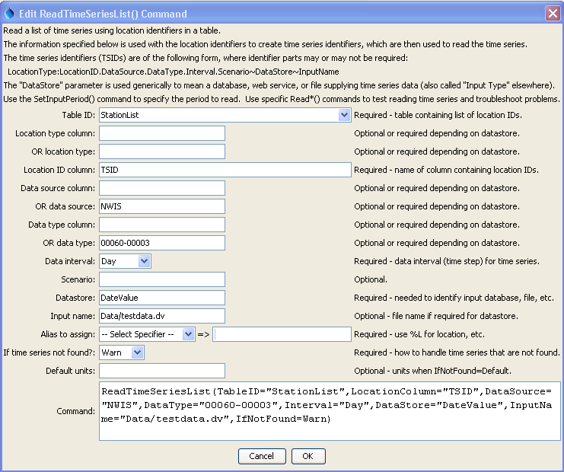
ReadTimeSeriesList
ReadTimeSeriesList() Command Editor

The command syntax is as follows:

ReadTimeSeriesList(Parameter=Value, …)

Command Parameters

Parameter | Description | Default
TableID | The identifier for the table that provides the list of location identifiers. | None – must be specified.
LocationType  Column | The column in the table containing the location type to use in time series identifiers. Specify LocationTypeColumn or LocationType. | May or may not be required, depending on the datastore or input type.
LocationType | The location type in the time series identifier. Specify LocationTypeColumn or LocationType. | May or may not be required, depending on the datastore or input type.
LocationColumn | The column in the table containing the location identifiers to use in time series identifiers. | None – must be specified.
DataSource  Column | The column in the table containing the data source to use in time series identifiers. Specify DataSourceColumn or DataSource. | May or may not be required, depending on the datastore or input type.
DataSource | The data source(s) in the time series identifier, separated by commas. For example, if using the State of Colorado’s HydroBase, USGS indicates that data are from the United States Geological Survey and DWR are from the Division of Water Resources. If multiple data sources are specified, each will be tried until a time series is found. This is enabled because sometimes gages change ownership. Specify DataSourceColumn or DataSource. | May or may not be required, depending on the datastore or input type
DataType  Column | The column in the table containing the data type to use in time series identifiers. Specify DataTypeColumn or DataType. | Data type is often required
DataType | The data type in the time series identifier. For example, if using the State of Colorado’s HydroBase, DivTotal is used for diversion totals. Specify DataTypeColumn or DataType. | Data type is often required
Interval | Data interval in the time series identifier, using standard values such as 15Minute, 6Hour, Day, Month, Year. | None – must be specified.
Scenario | Scenario in the time series identifier. | Usually not required.
DataStore | The data store (or input type) in the time series identifier. Refer to the datastore and input type appendices or the TSTool main GUI for options. | None – must be specified.
InputName | The input name in the time series identifier, when a file name is required. | Generally only required when reading from a file.
IfNotFound | Indicates how to handle missing time series, one of:  - Warn – generate fatal warnings and do not include in output.  - Ignore – generate non-fatal warnings and do not include in output.  - Default – generate non-fatal warnings and create empty time series for those that could not be found. This requires that a SetOutputPeriod() command be used before the command to define the period for default time series. | Warn
DefaultUnits | Default units when IfNotFound=Default. | Blank – no units.

A sample command file to process monthly diversion data from the State of Colorado’s HydroBase database is as follows:

# Read monthly diversion total from HydroBase for the structures in the list
# file. The data source is set to DWR because data source is saved in
# HydroBase.
ReadTimeSeriesList(TableID=”Diversions.csv",LocationColumn=”WDID”,
DataSource=DWR,DataType=DivTotal,Interval=Month,InputType=HydroBase,
IfNotFound=Default)

