Command Reference: CopyTable()
Create a table as a (partial) copy of a table
Version 10.22.00, 2013-08-08

The CopyTable() command copies all or a subset of the columns from one table to create a new table. For example, this is useful to create one-column lists that can be used to expand template files with the ExpandTemplateFile() command, or to create a subset of columns to output to a file or write to a database.

The following dialog is used to edit the command and illustrates the syntax of the command (in this case illustrating how values in a column named LocationID are copied to a new table).

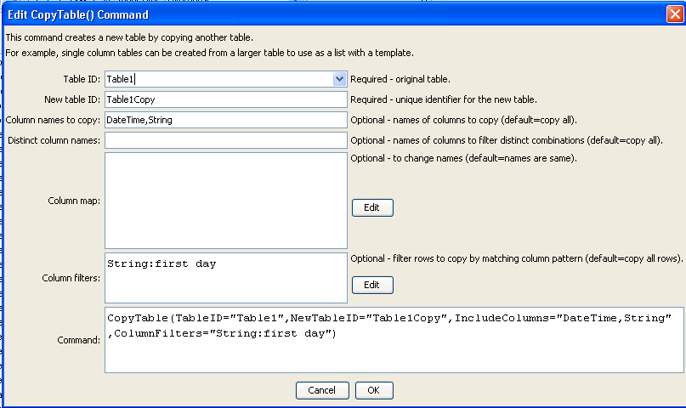
CopyTable
CopyTable() Command Editor

The command syntax is as follows:

CopyTable(Parameter=Value,…)

Command Parameters

Parameter | Description | Default
TableID | The identifier for the original table. | None – must be specified.
NewTableID | The identifier for the new table. | None – must be specified.
IncludeColumns | The names of columns to copy, separated by commas. | Copy all of the columns.
DistinctColumns | The names of columns to copy, separated by commas. Only distinct values from the specified column will be copied. For example, if column A contains strings X, Y, Z, Y, C, the resulting distinct value column will have rows with X, Y, Z, C. Currently only one column name can be specified but in the future more than one column may be allowed.  This parameter overrides IncludeColumns. | Don’t do a distinct comparison.
ColumnMap | The new names for the output columns, using syntax:  OriginalColumn1:NewColumn1, OriginalColumn2:NewColumn2 | The column names in the copy will be the same as in the original table.
ColumnFilters | Filters that limit the number of rows being copied, using the syntax:  FilterColumn1:FilterPattern1, FilterColumn2:FilterPattern2  Patterns can use * to indicate wildcards for matches. Only string values can be checked (other data types are converted to strings for comparison). Comparisons are case-independent. All patterns must be matched in order to copy the row. In the future a command may be added to perform queries on tables, similar to SQL for databases. | No filtering.

