Command Reference: SetAutoExtendPeriod()
Set whether time series periods should automatically be extended to the output period
Version 08.16.03, 2008-07-29

By default, the time series period is extended to include the output period, if specified, when a time series is read. See also the SetOutputPeriod() command. If the extended period subsequently contains missing data, it can be filled with other commands. The SetAutoExtendPeriod() command can be used to change this setting if it is not desirable (e.g., for performance reasons).

The following dialog is used to edit the command and illustrates the command syntax.

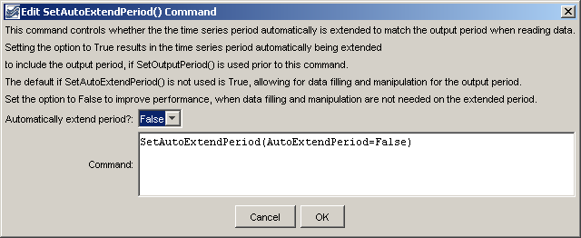
SetAutoExtendPeriod
SetAutoExtendPeriod() Command Editor

The command syntax is as follows:

SetAutoExtendPeriod(Parameter=Value,…)

Command Parameters

Parameter | Description | Default
AutoExtendPeriod | Indicate whether the period of time series should automatically be extended to the output period when time series are read, True or False. | None – must be specified. The default is True if this command is not used.

A sample command file is as follows:

SetAutoExtendPeriod(AutoExtendPeriod=False)

This page is intentionally blank.

